**Design Hybrid Framework**

Setup TestNG.

Setup Maven

Create Maven project.

Update pom.xml as guided below.

First screenshot adding selenium dependency under mevan project in pom.xml

Second screenshot explains how dependency updated under pom.xml

Third screenshot explains where to get latest TestNG dependency.

Forth screenshot past above copied code and modify scope as: compile (instead of: test)

Using attached pom.pdf, copy and paste all the Apache POI API dependency to the pom.xml file.(we will be using for data driven point of view)

Fifth screenshot explains creating packages under mevan project.

Sixth screenshot explains, creating config.properties file with details.

Seventh screenshot explains, created page classes.(POM)

Eighth screenshot explains, creating **baseclass** under base package, created constructor and initilized prop by referring path of config.prop file.

**Note: make public static to make accessible in page classes.(POM)**

Ninth screenshot explains creating initilization method for Browsers under **baseclass.**

Tenth screenshot explains, creating TestUtil class under Util package.

Eleventh screenshot explains, defining manage timeout....Defining time out values taken from TestUtil class.

Twelth screenshot explains, update extend BaseClass to all the pages.(POM)

Thirteenth screenshot explains defining page factory for login page.(POM)

Forteenth screenshot explains initilization of page factory eleminates using constructor.

Note: **this** represent loginpage class object.

**Que**:Method to initilize page factory elements?

**Ans**:Property.initElements**(driver, this);**

Fifteenth screenshot explains creating methods for loginpage (POM)

Sixteenth screenshot explains creating test cases for loginpage.

Constructor, initilization, before and after annotations.

Seventh screenshot explains creating tests and run as TestNG.

https://docs.seleniumhq.org/download/maven.jsp

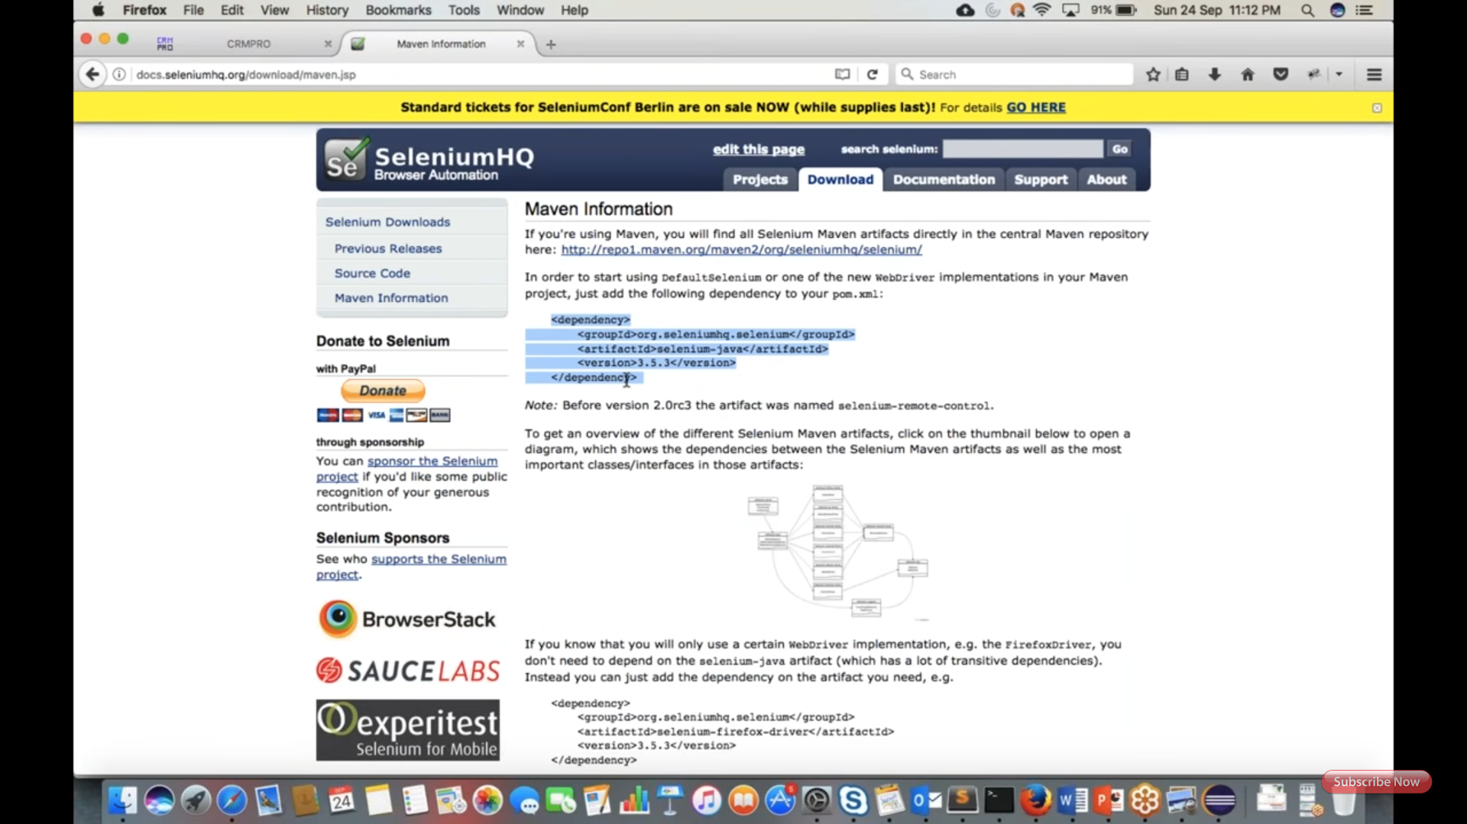

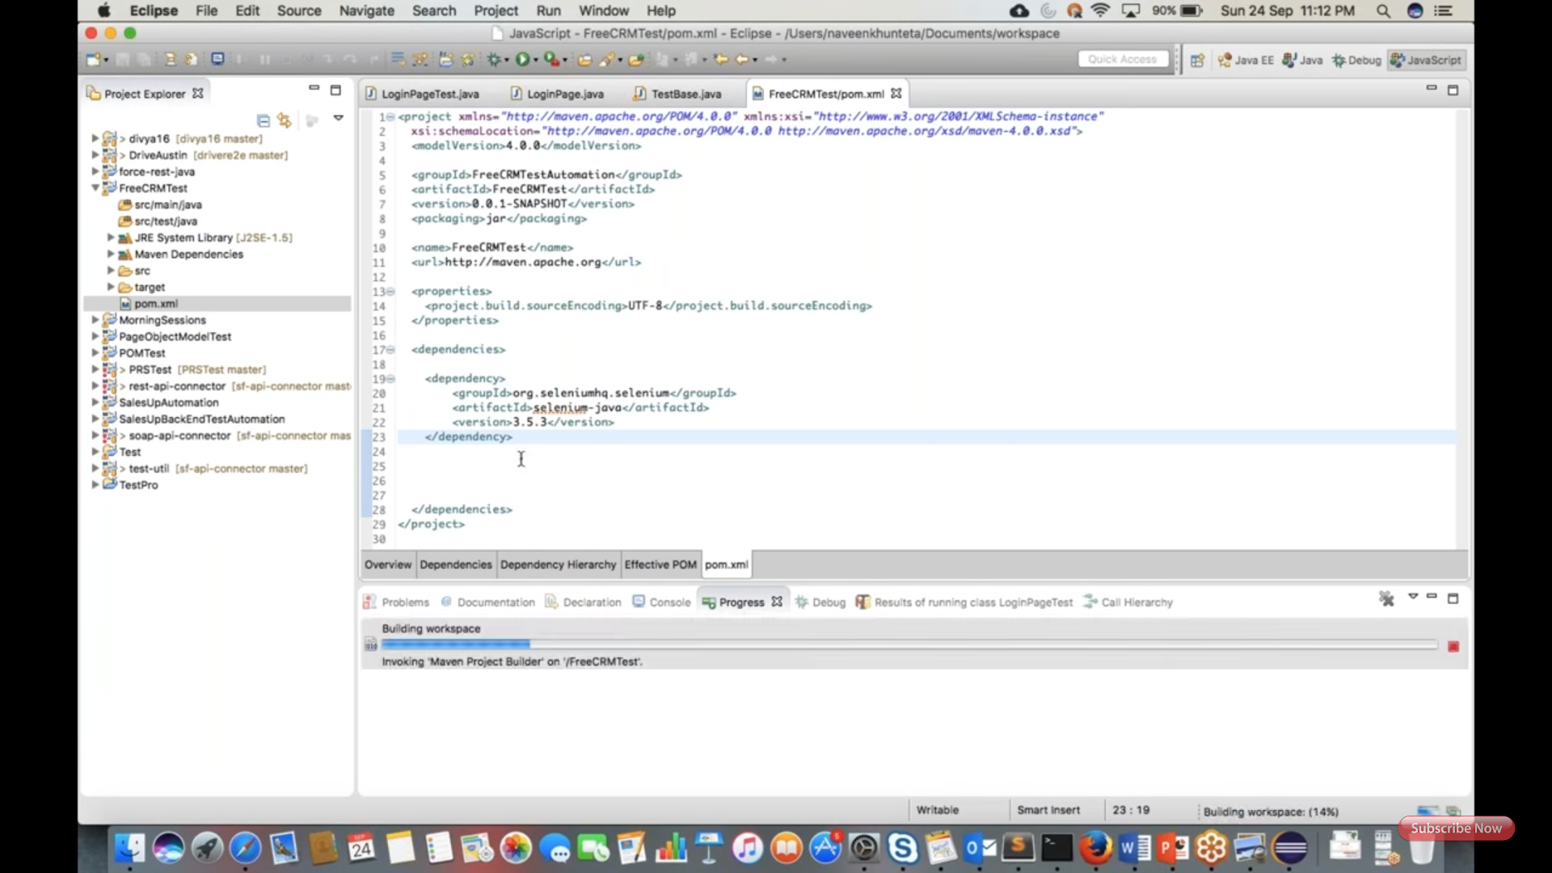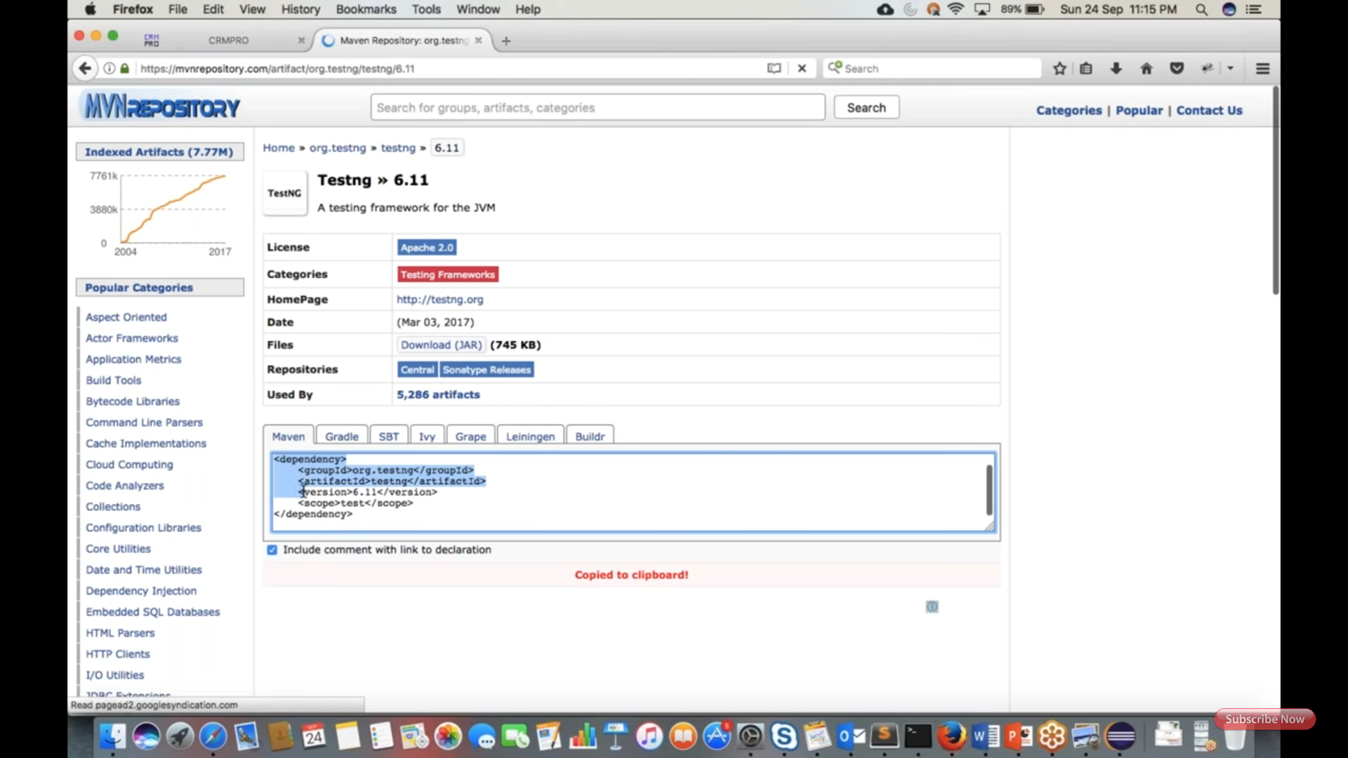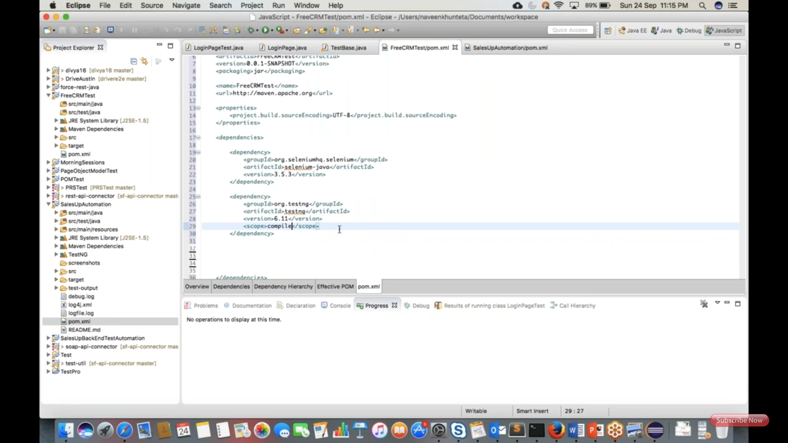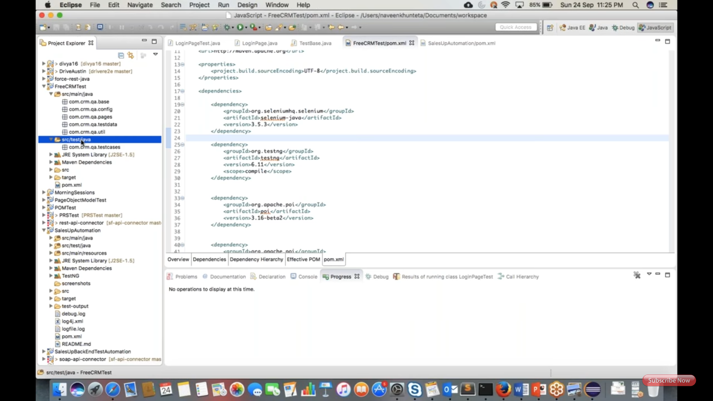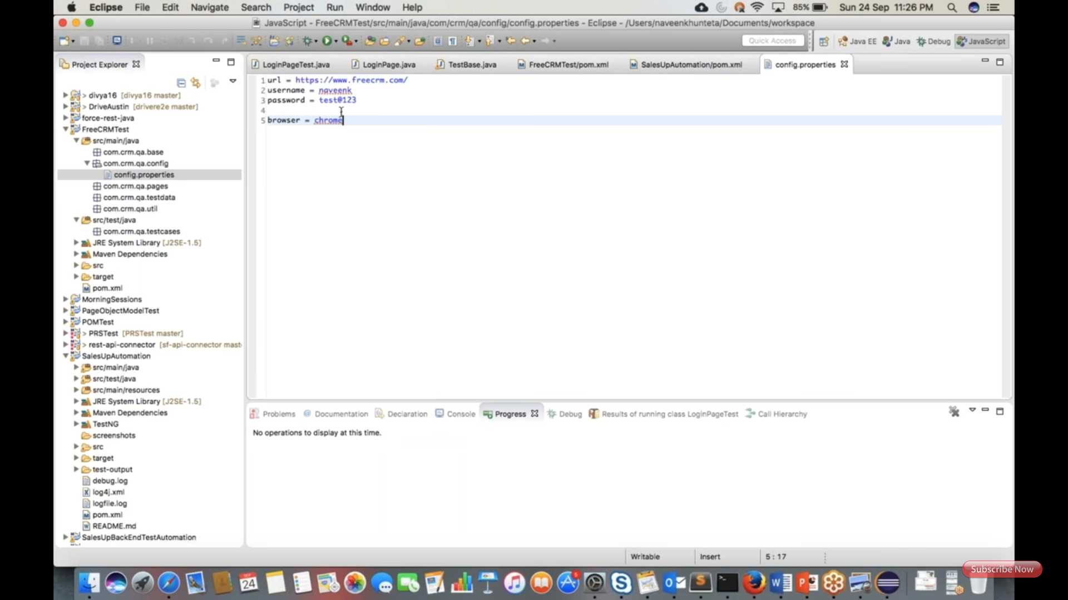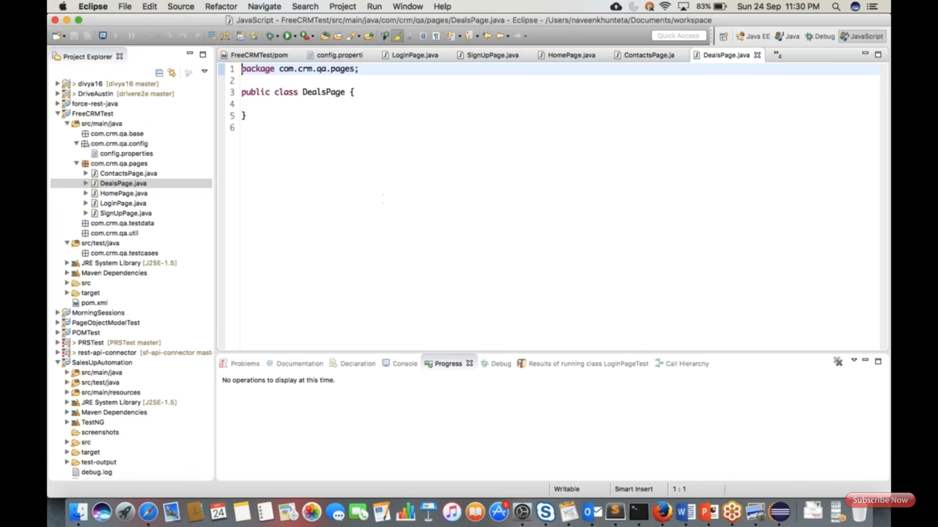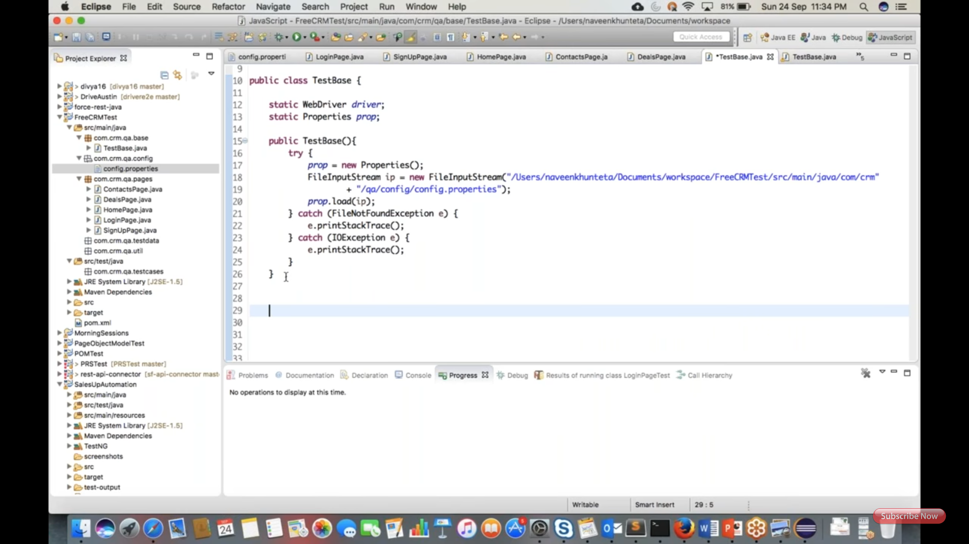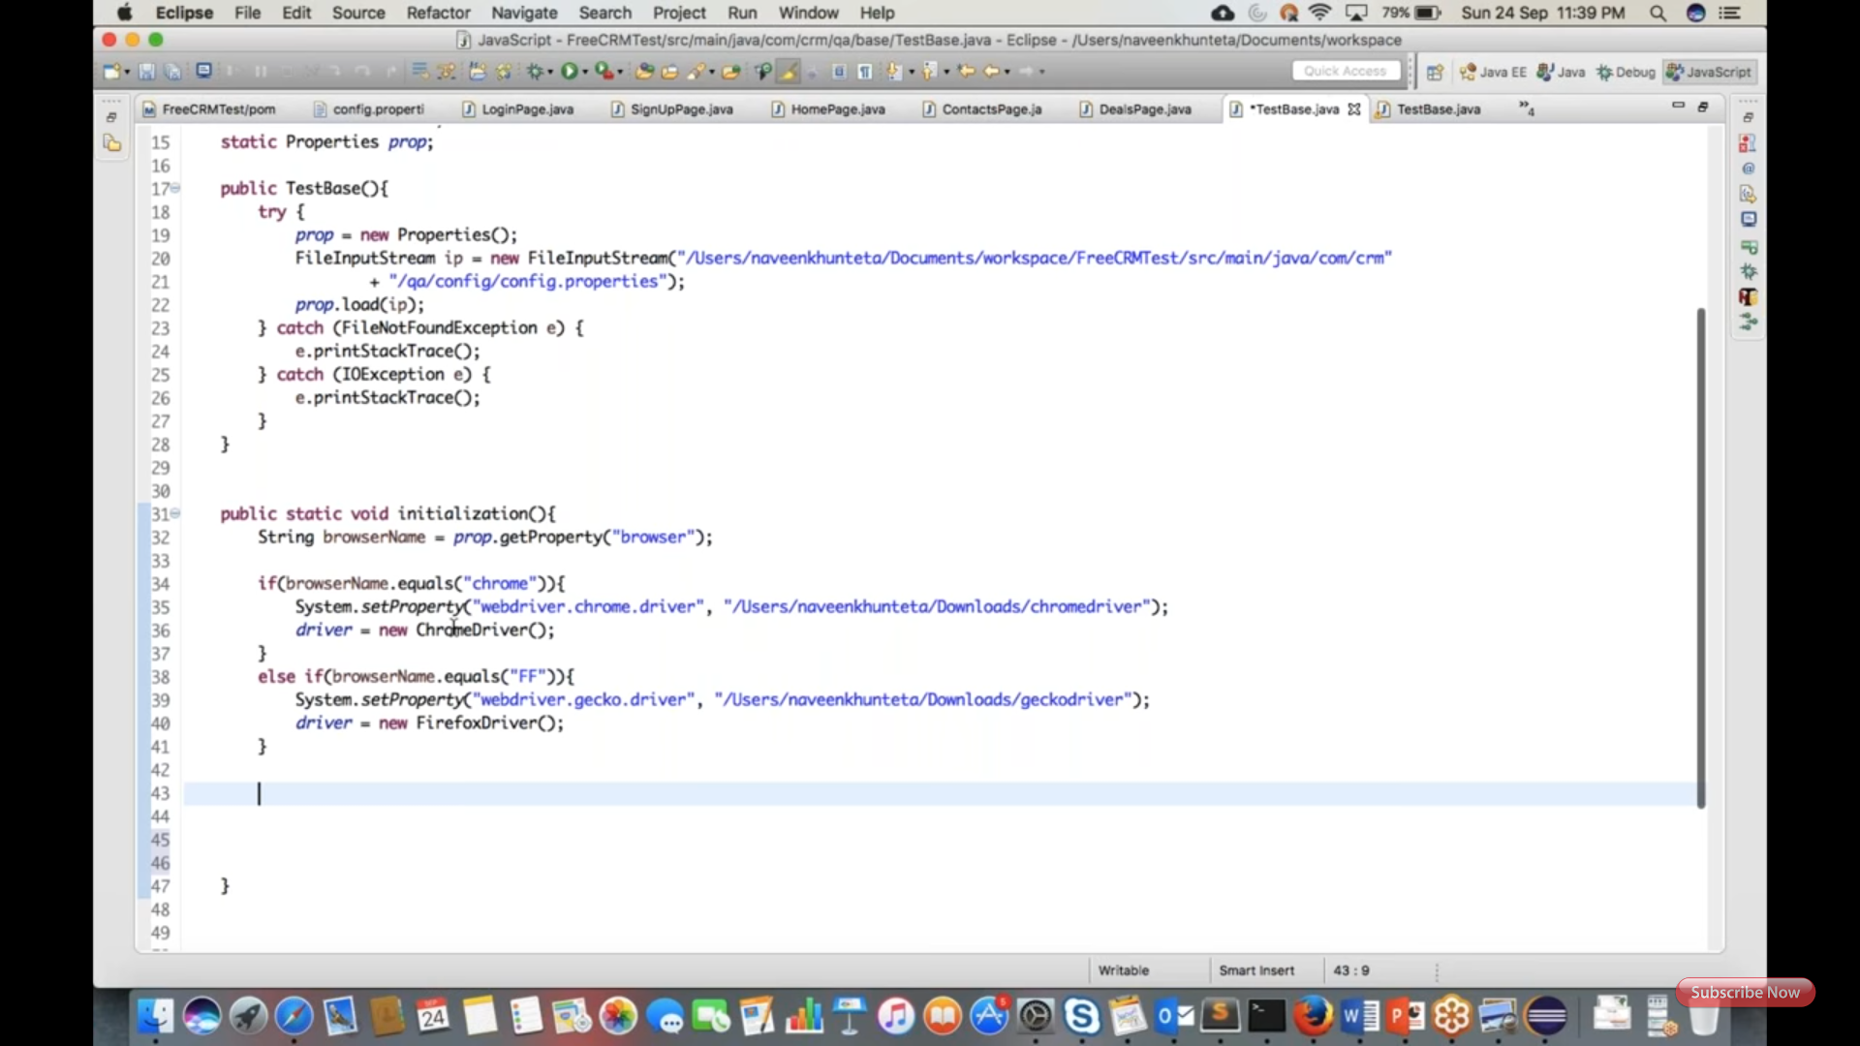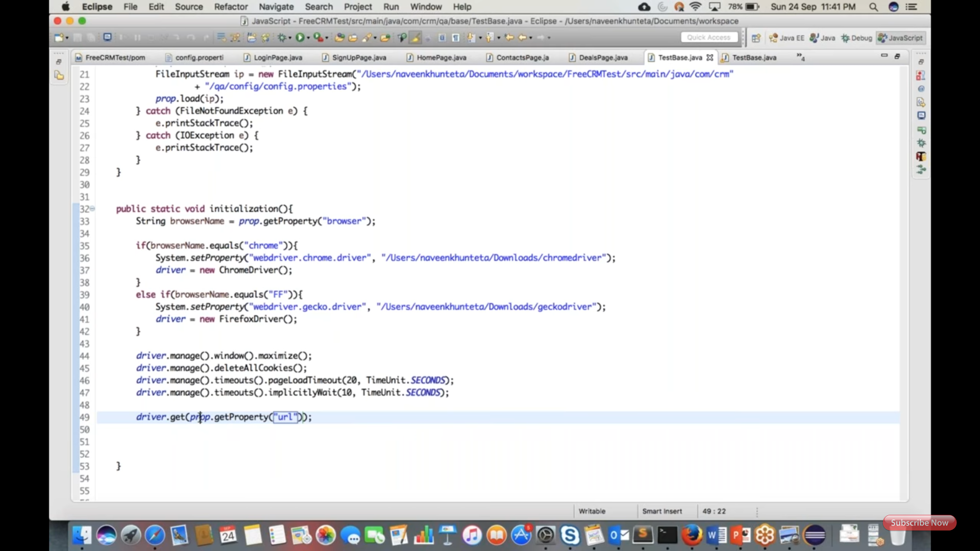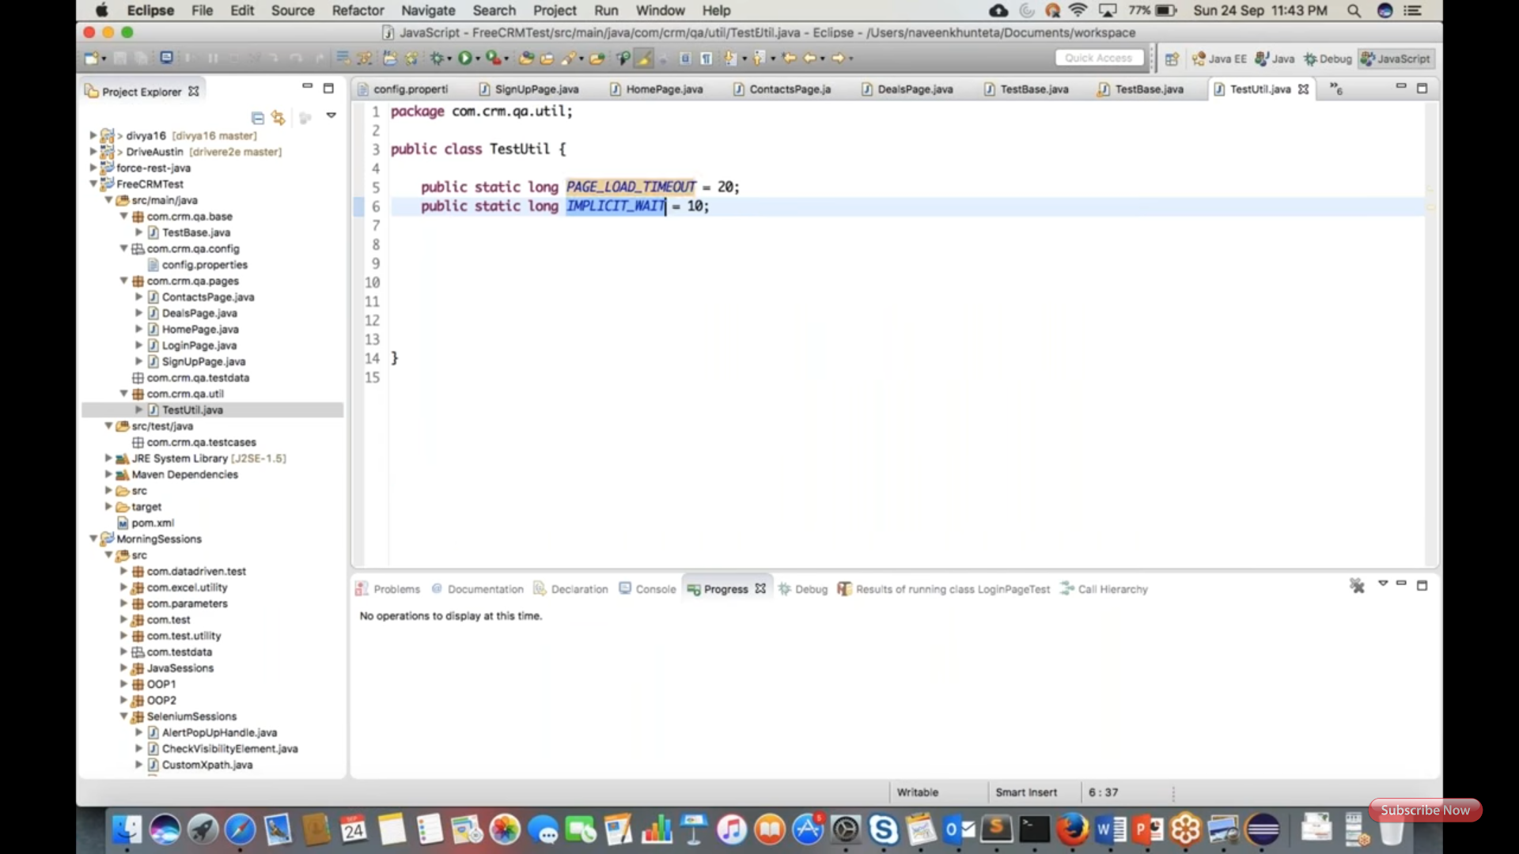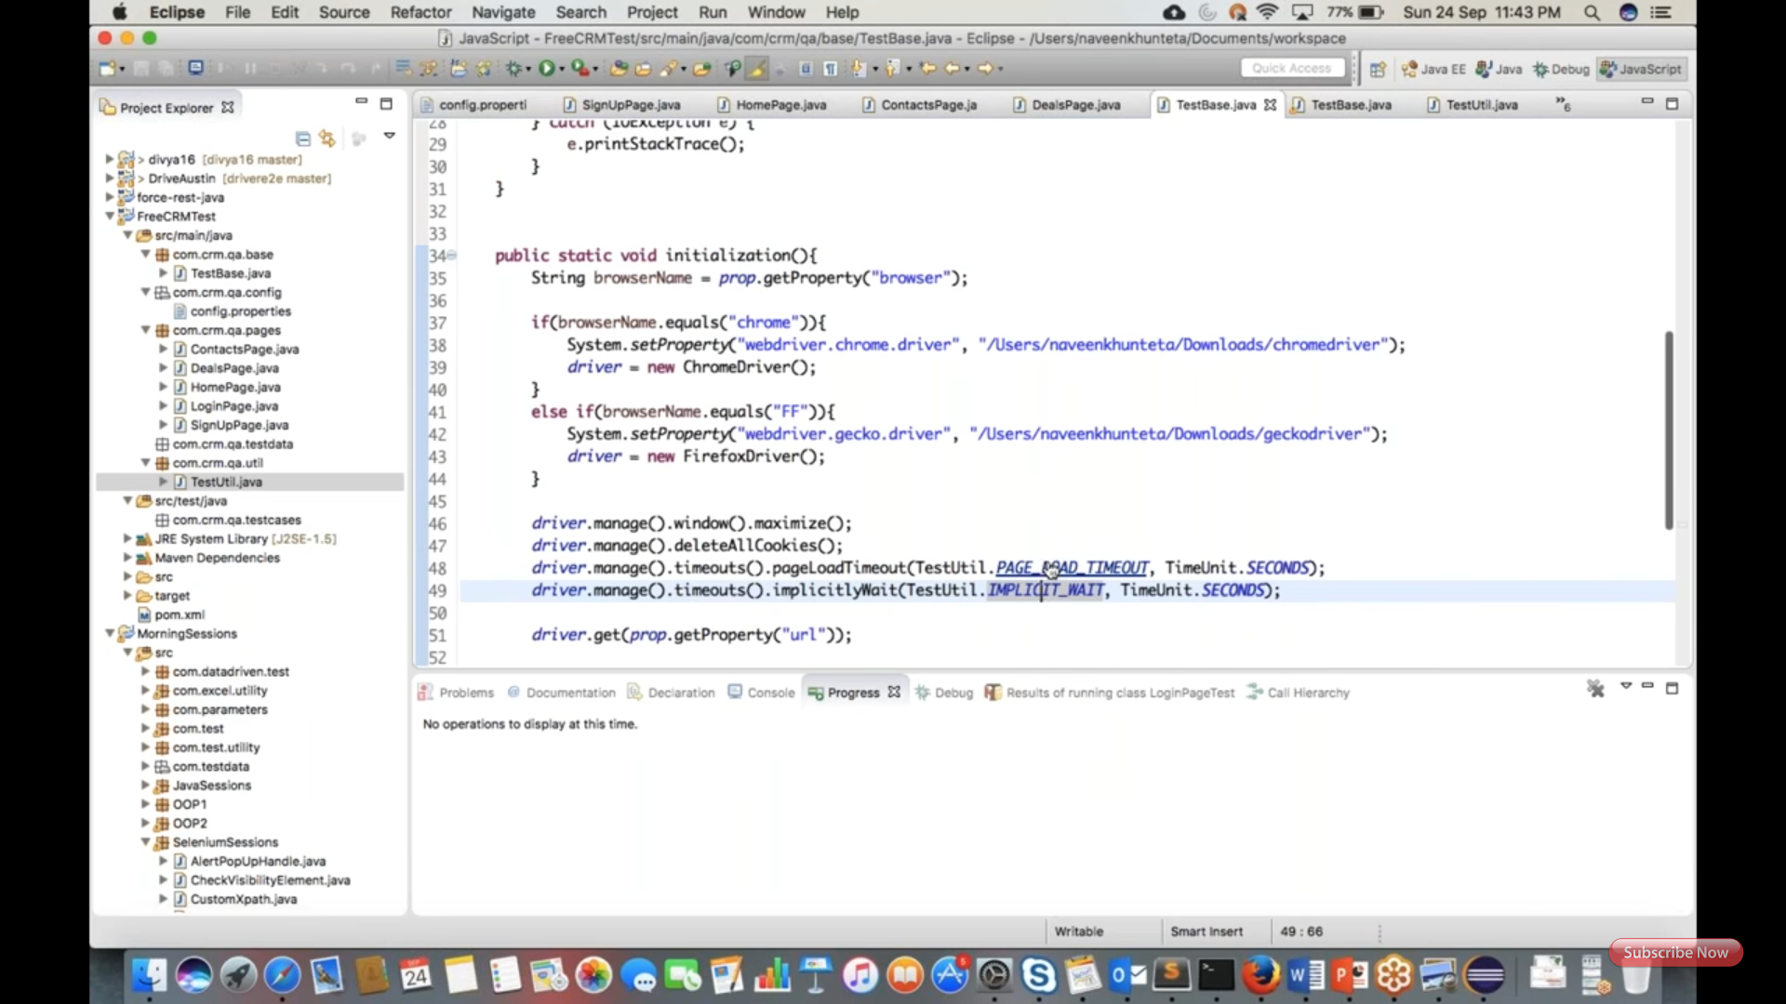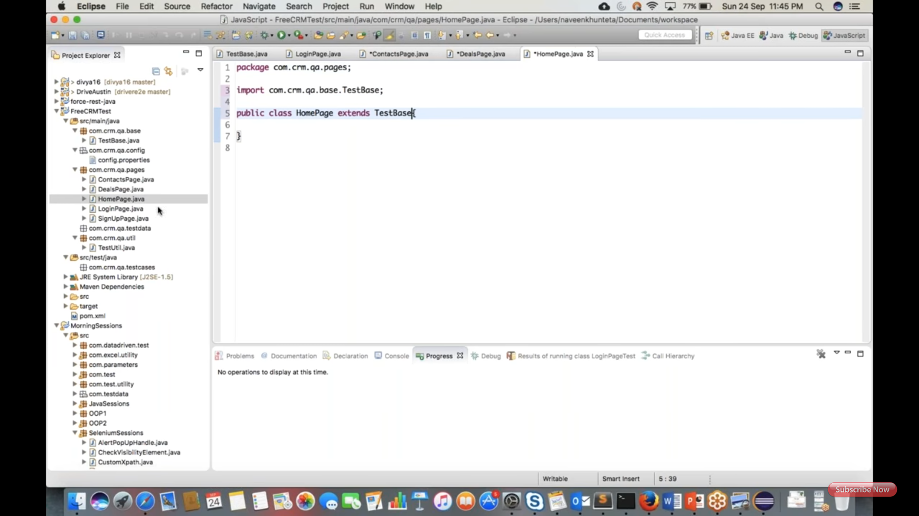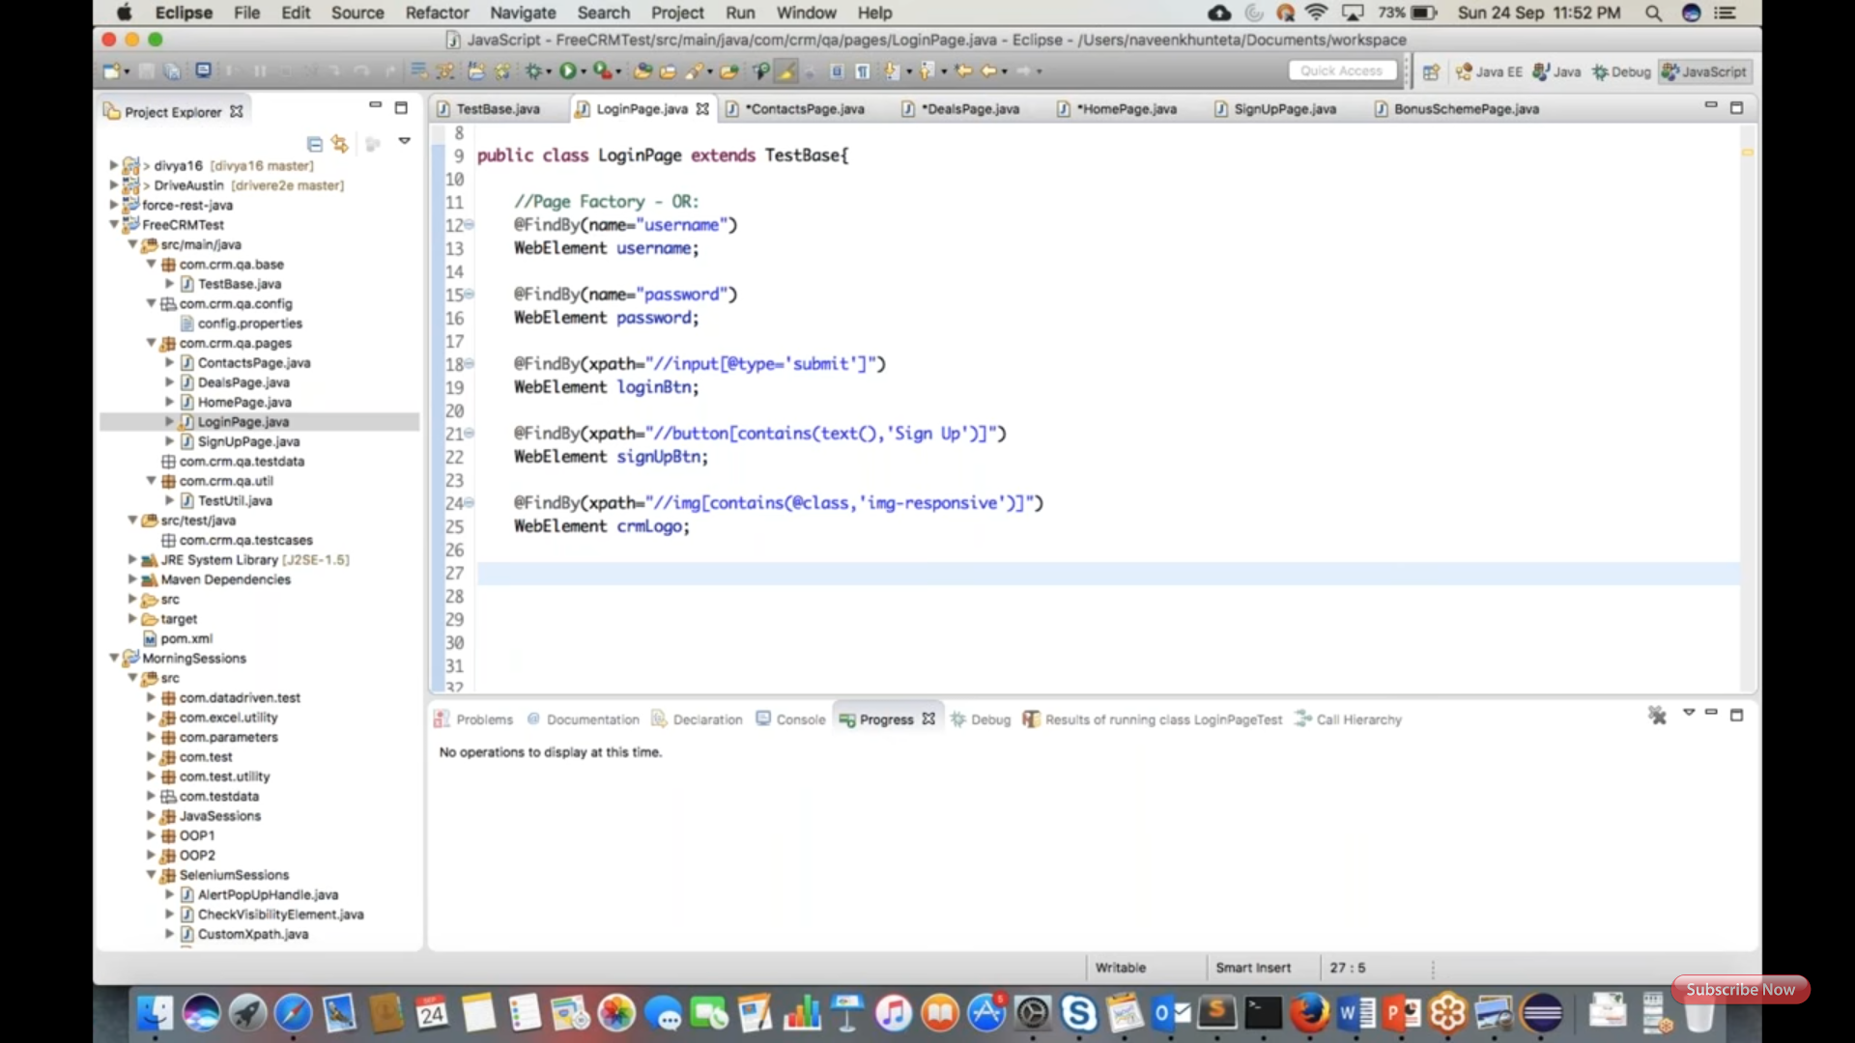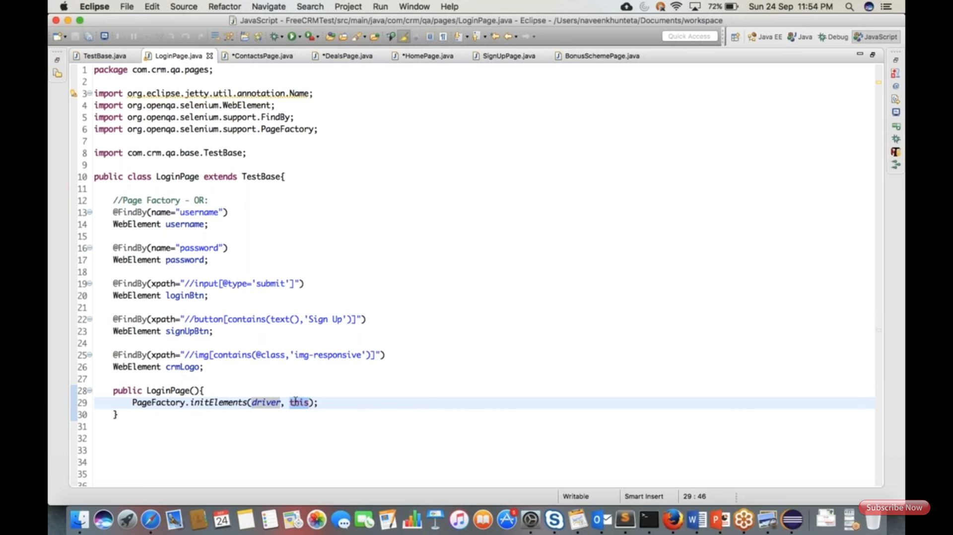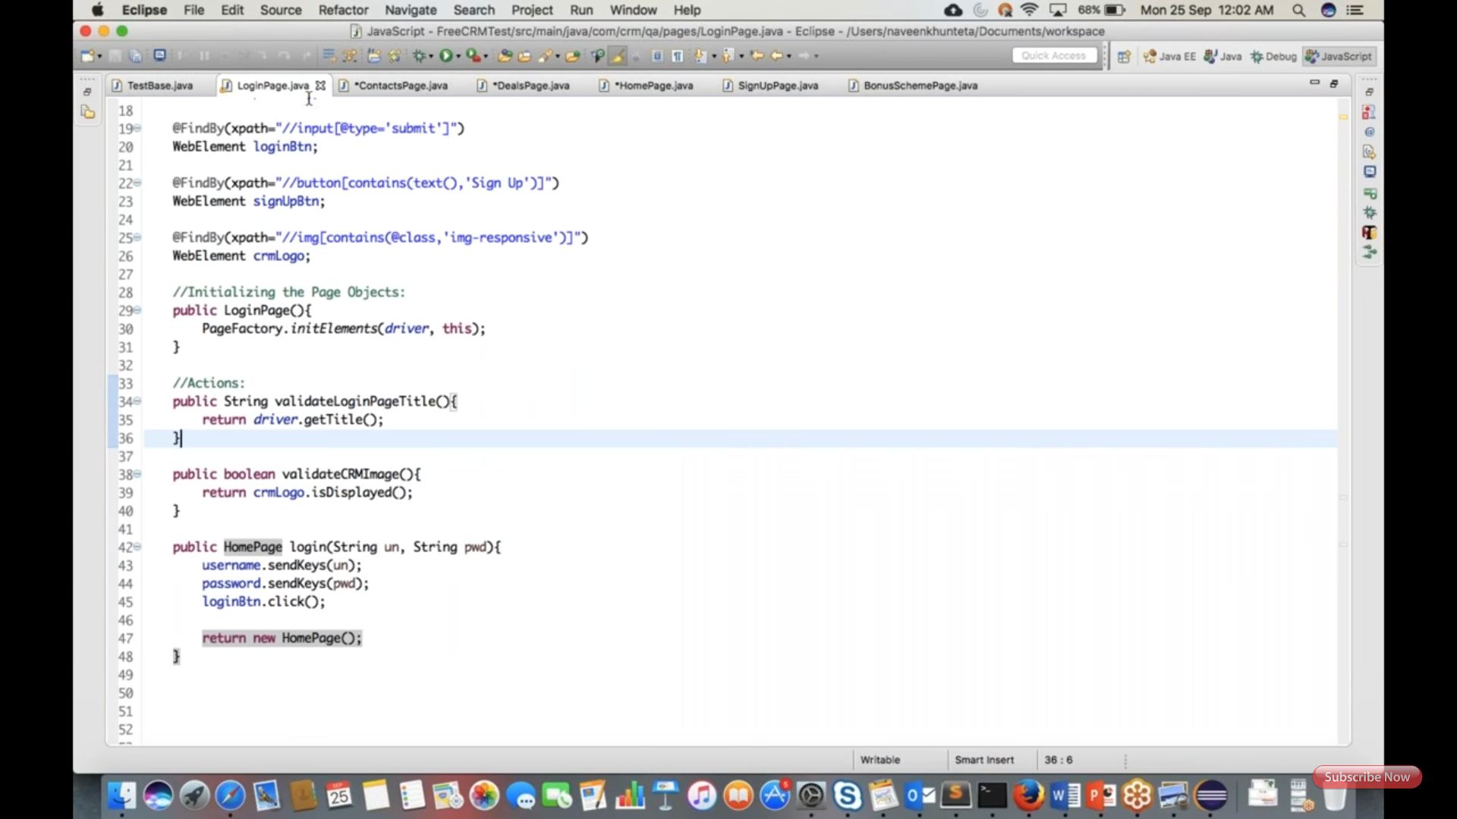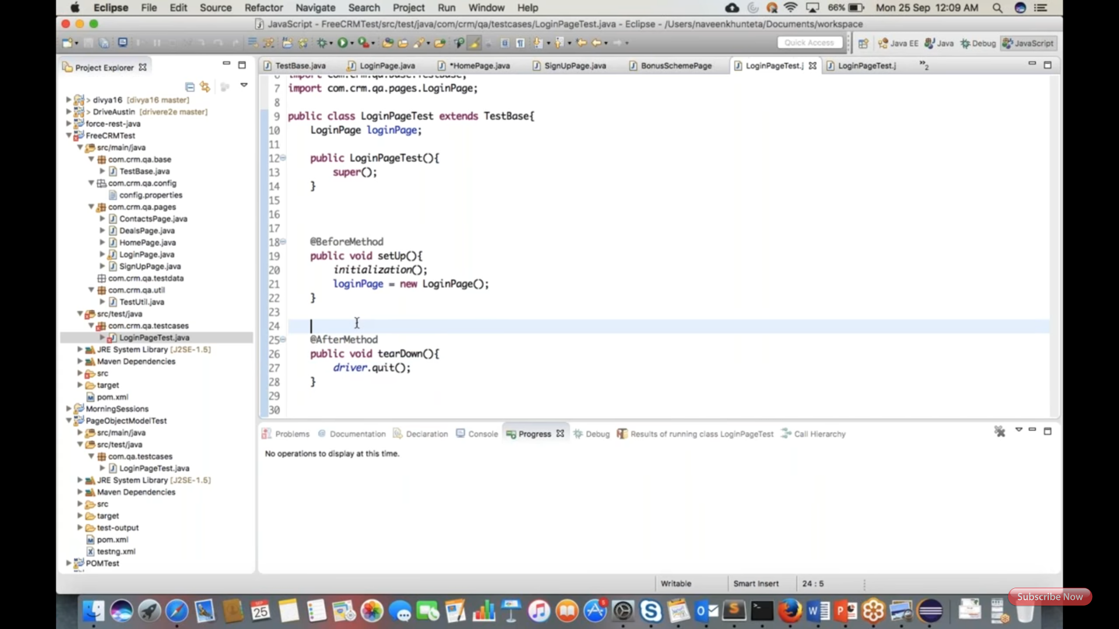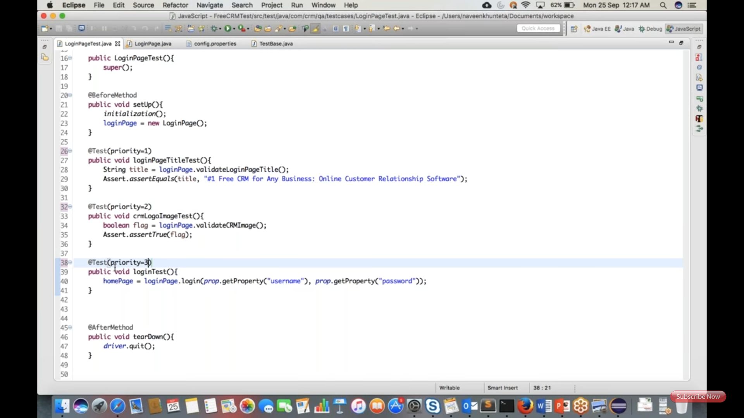

First screenshot explains home page, page factory.

Note: to import Java package, press Ctrl+Shift+O

Second screenshot explains home page method.

Third screenshot explains before and after methods. Here before method including login line.

Forth screenshot explains, method switchToFrame under Util class. Util class extended BaseTest class.

Fifth screenshot explains creating TestUtil object under Home page.

Sixth screenshot explains, initilize before method with TestUtil class.

Seventh screenshot explains, creation of test cases, one of the test case using switchTo calling.

**Note: for every other page objects, first declare, later initilize using @BeforeMethod and than use in test case method.**

Eighth screenshot explains, creation contactPage and using parameterized xpath directly to the testMethod, no page factory defined in such cases.

Ninth screenshot explains, contactPageTest before and after methods.

Tenth screenshot explains, creation of test cases under contactsPageTest

Eleventh screenshot explains, switch to frame Util class object and creation of contact Page object under before method.

Twelth screenshot explains, selecting single and multiple checboxes test cases under contract PageTest.

**To run multiple tese Classes: (creation of test runner class, i.e testng.xml, you can also create testng_sanity.xml, testng_regression.xml, so on. To run customized tests)**

Threeteeth screenshot explains, creation of the source folder under Maven main project.

Sixteenth screenshot explains, creation of the testng.xml file under source folder.

Seventh screenshot explains, design of testng.xml (press home+f2 get names of the classes)

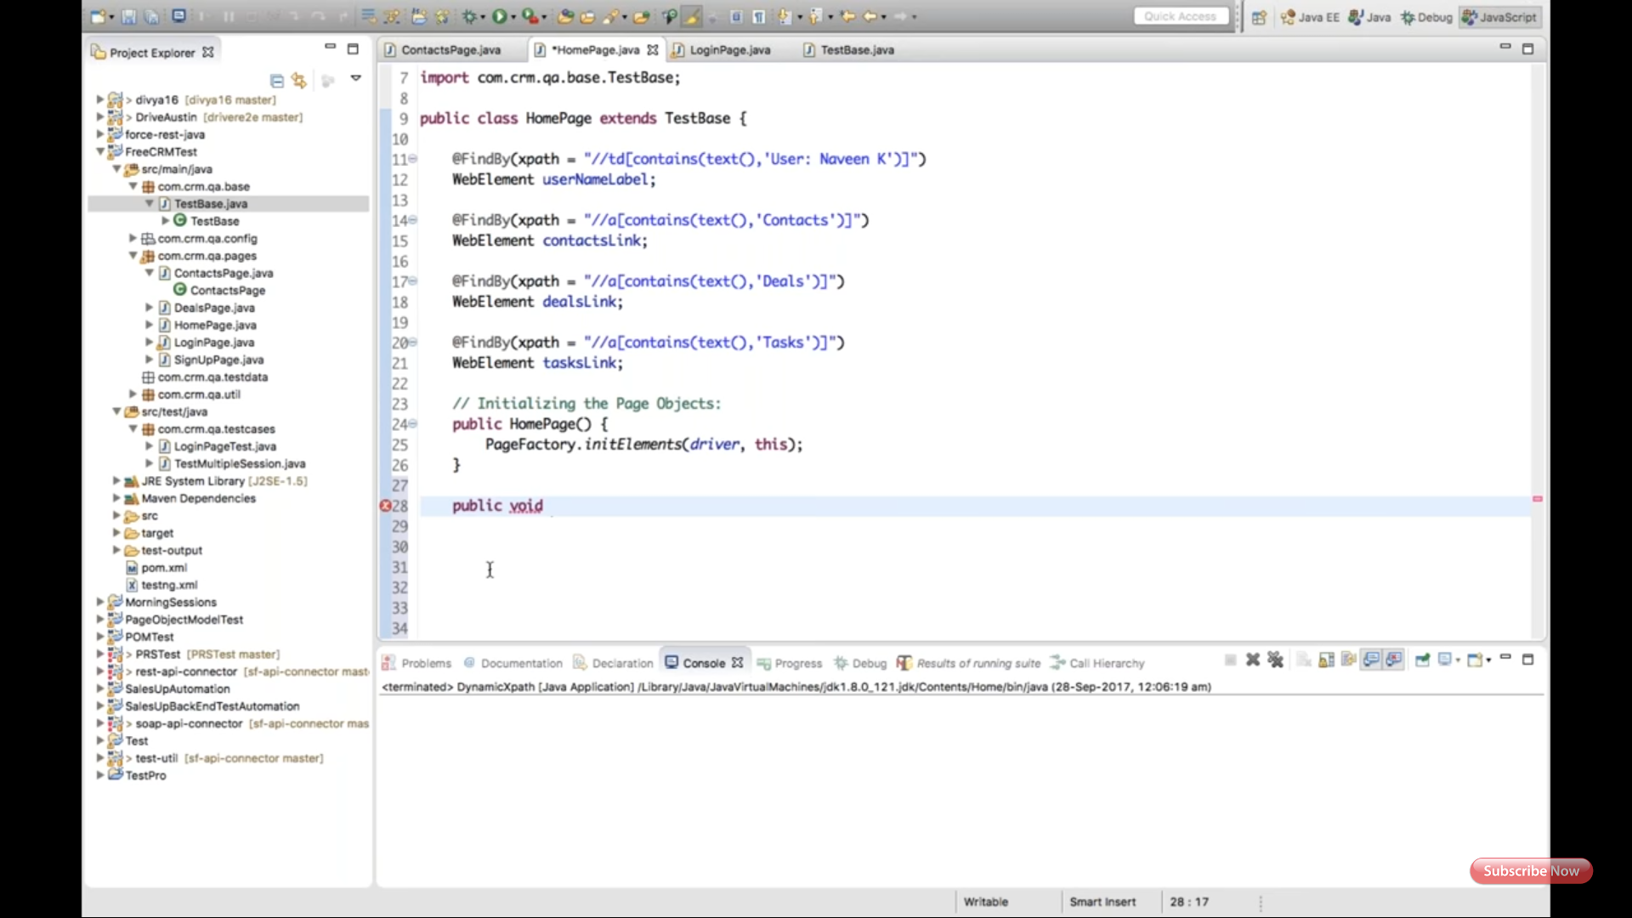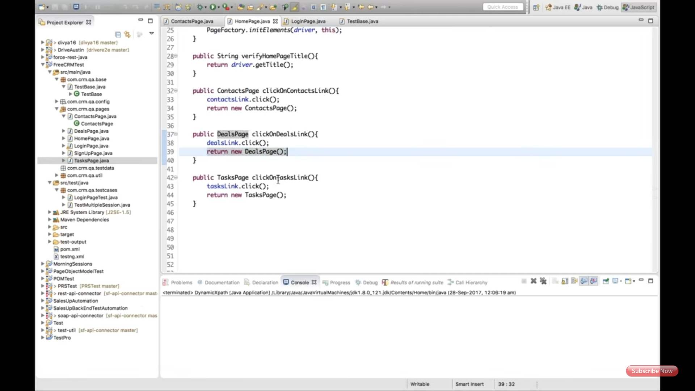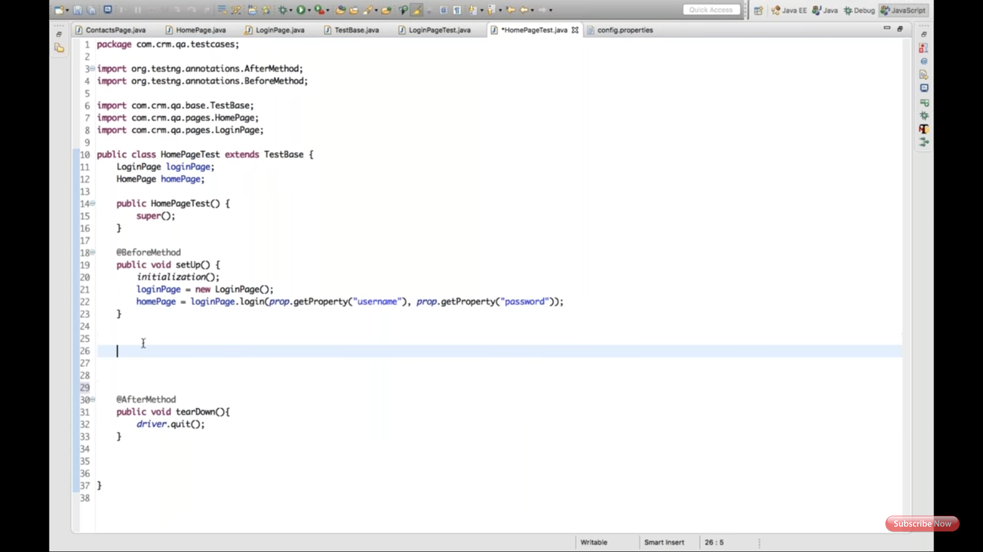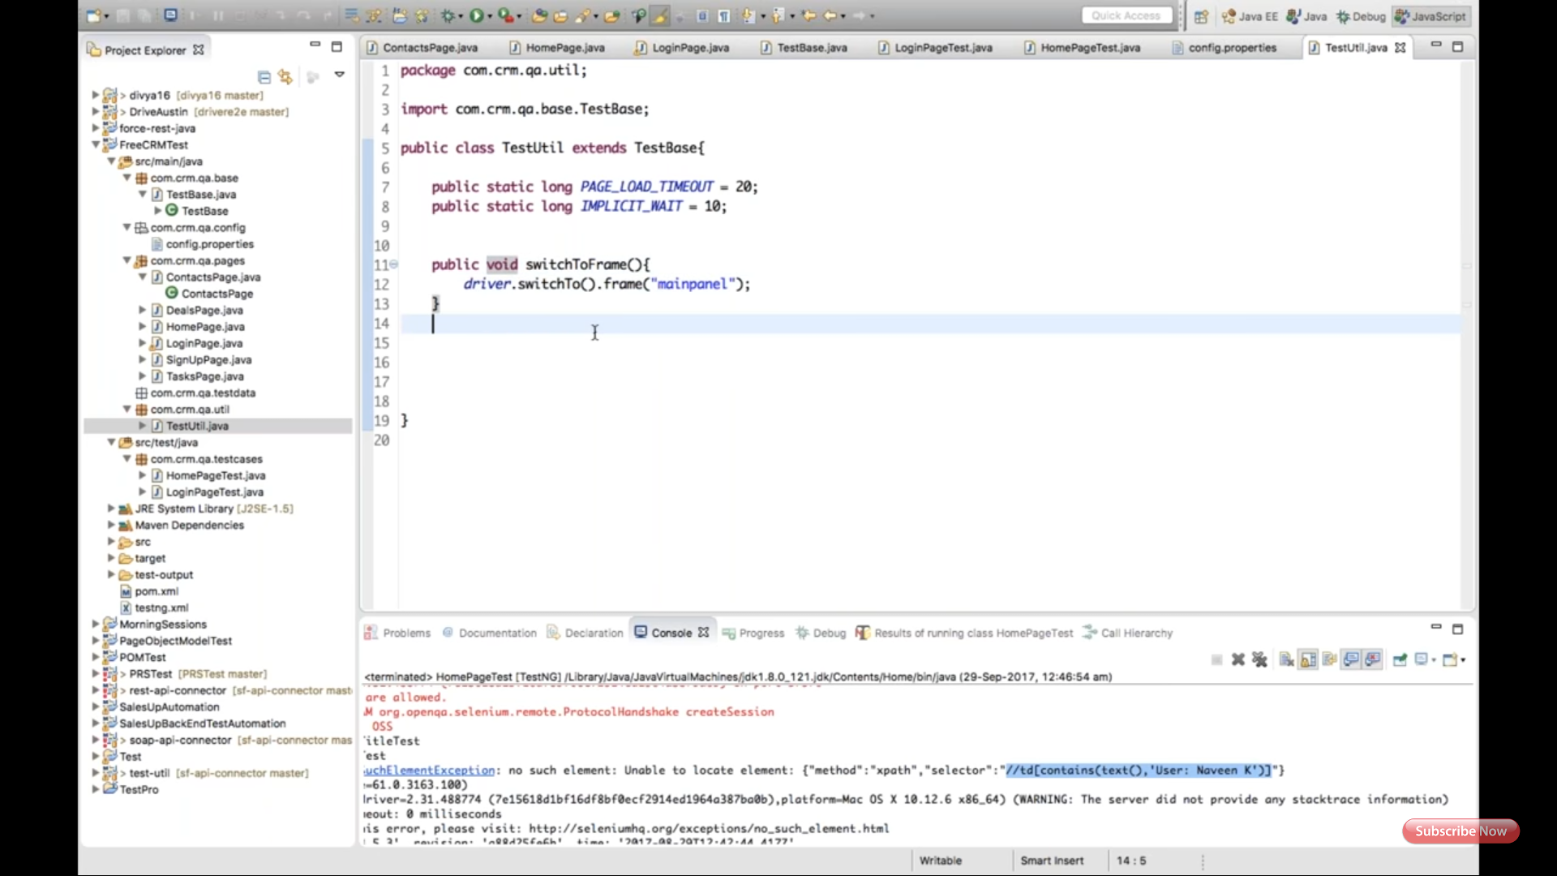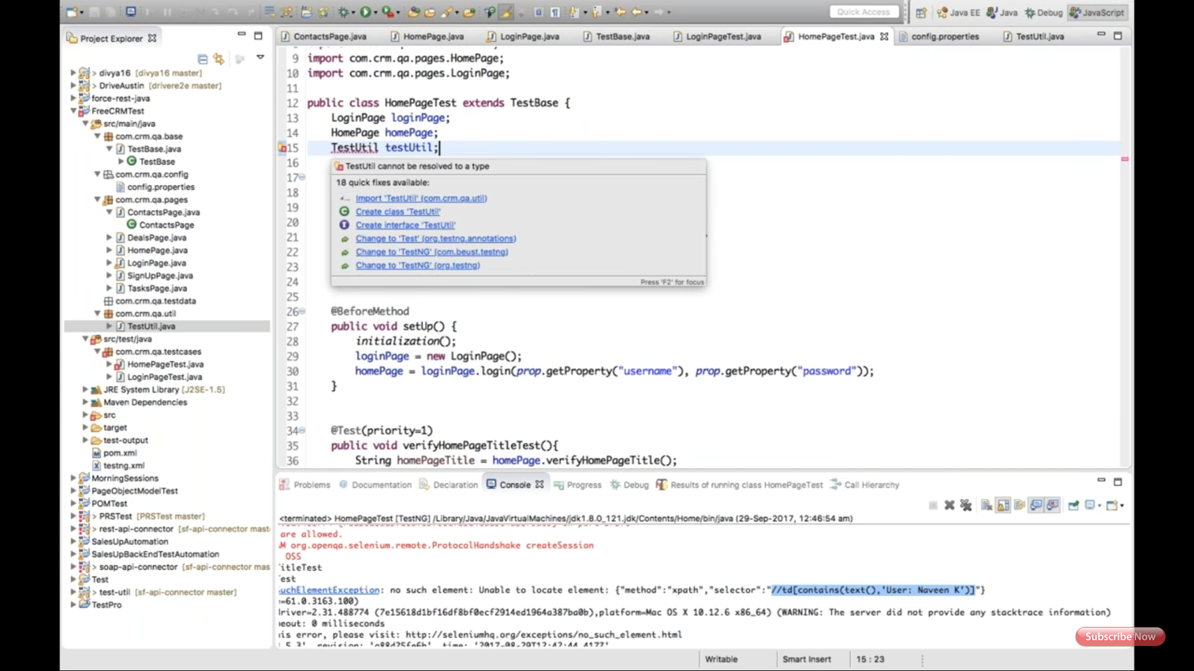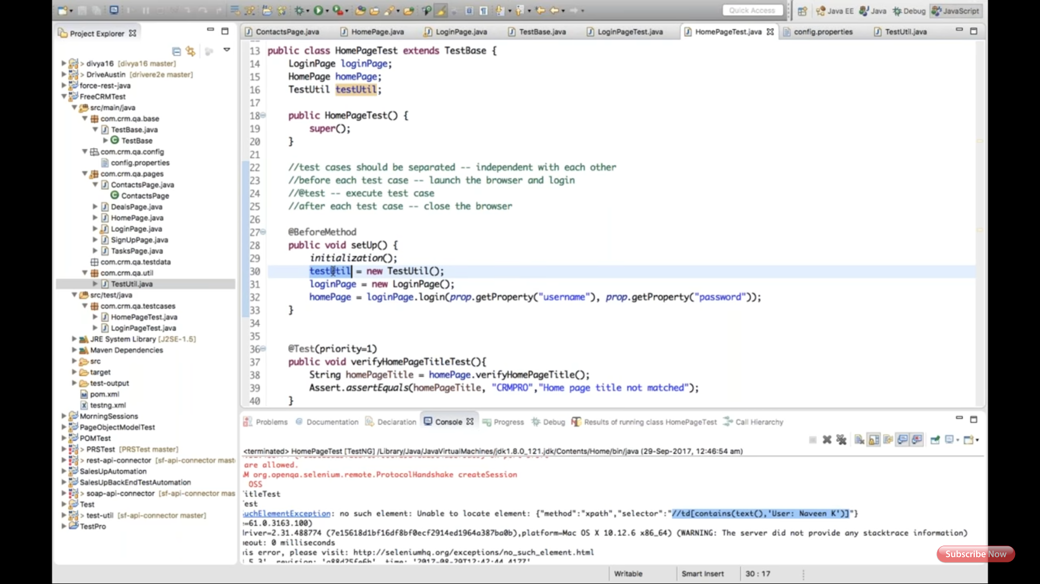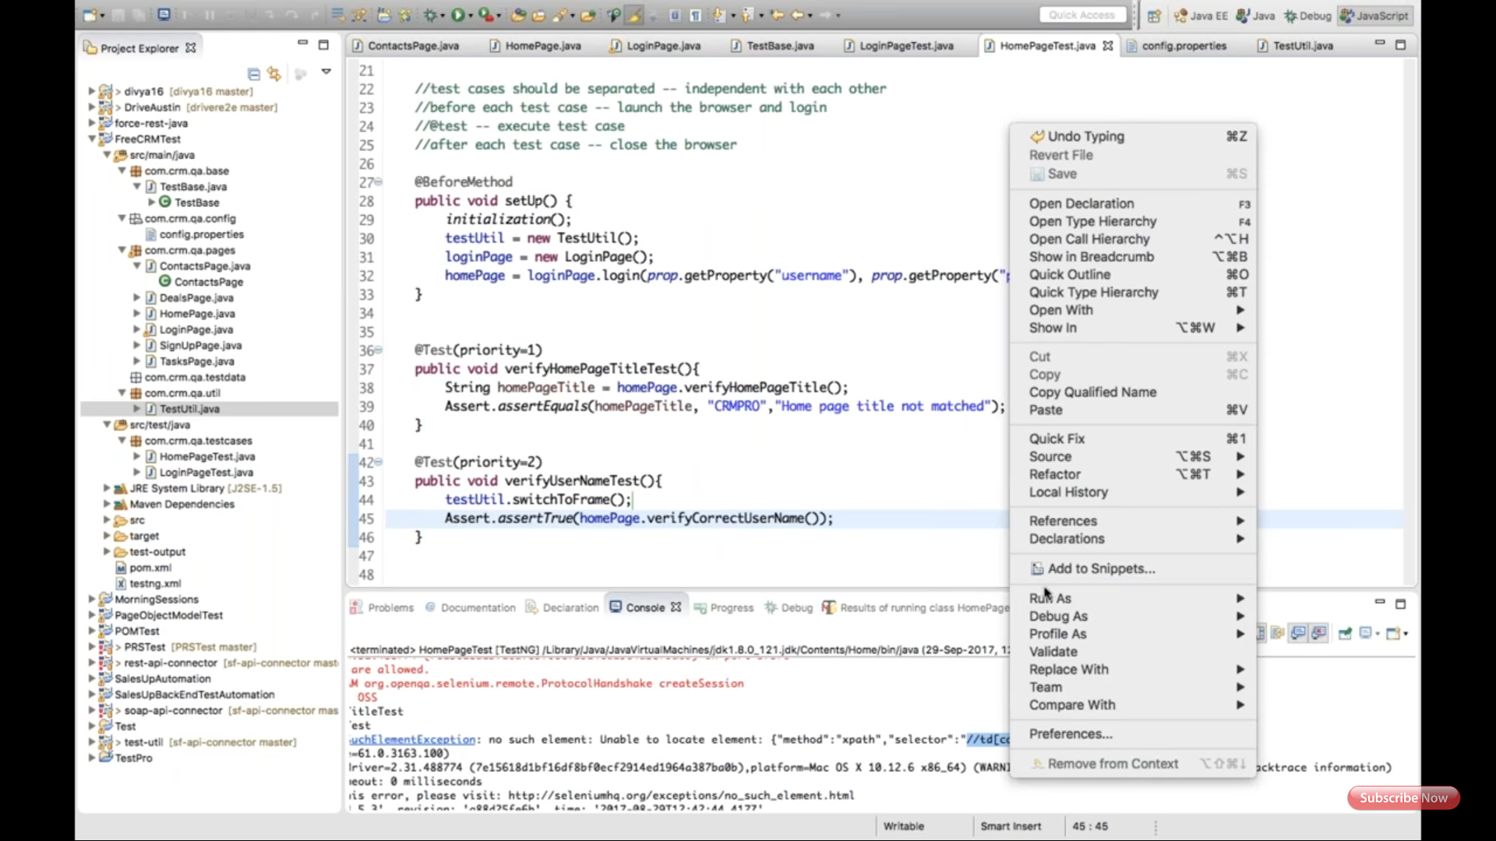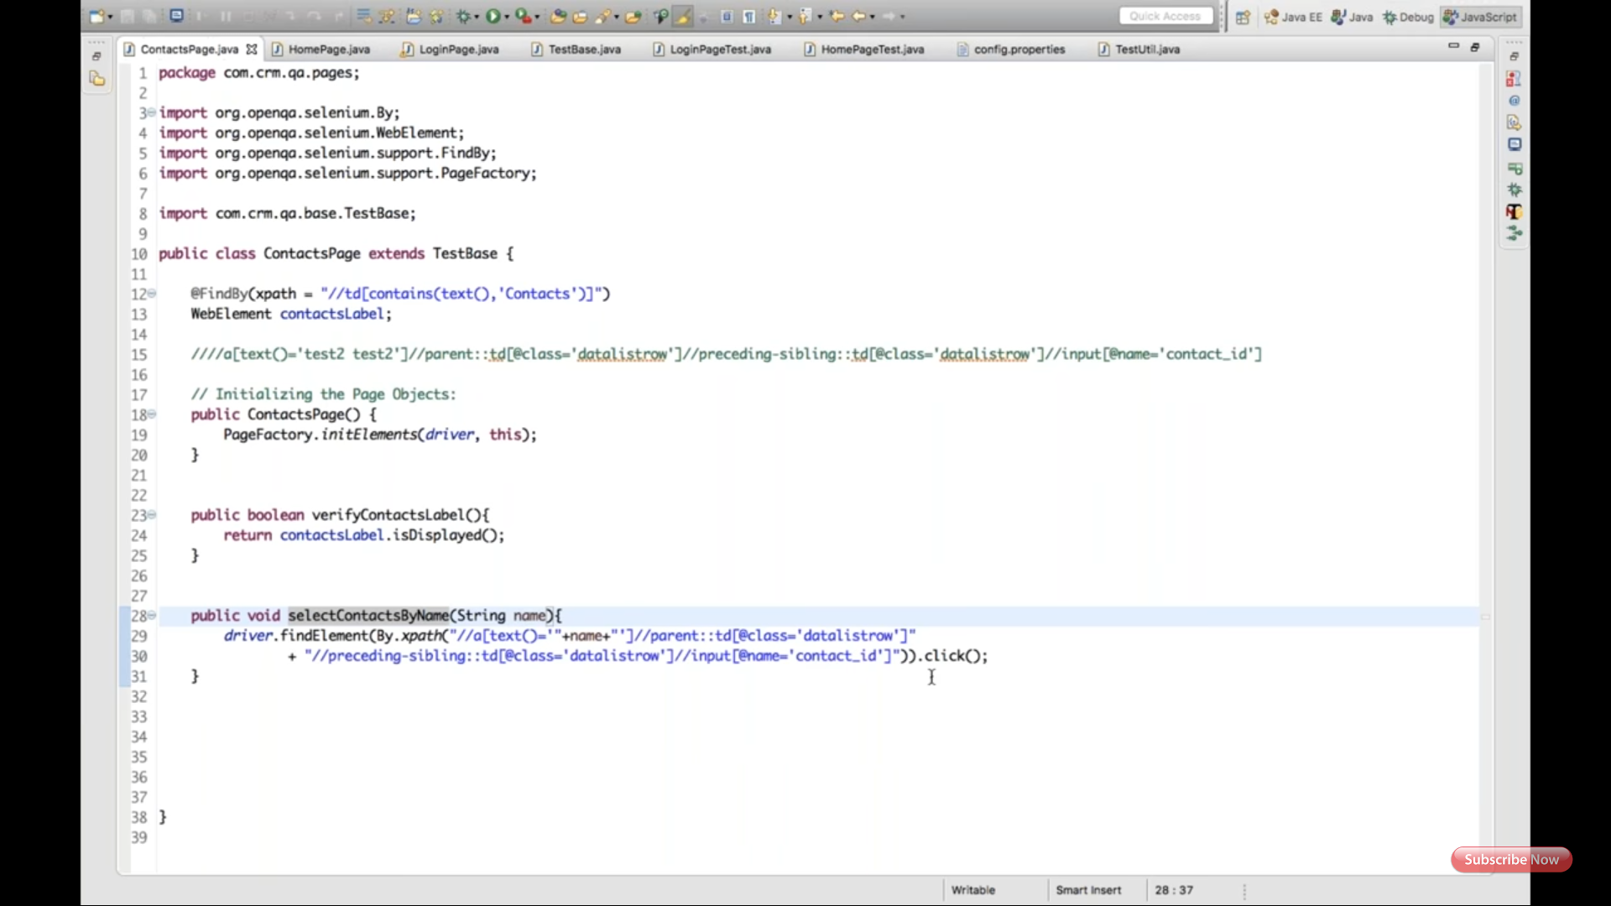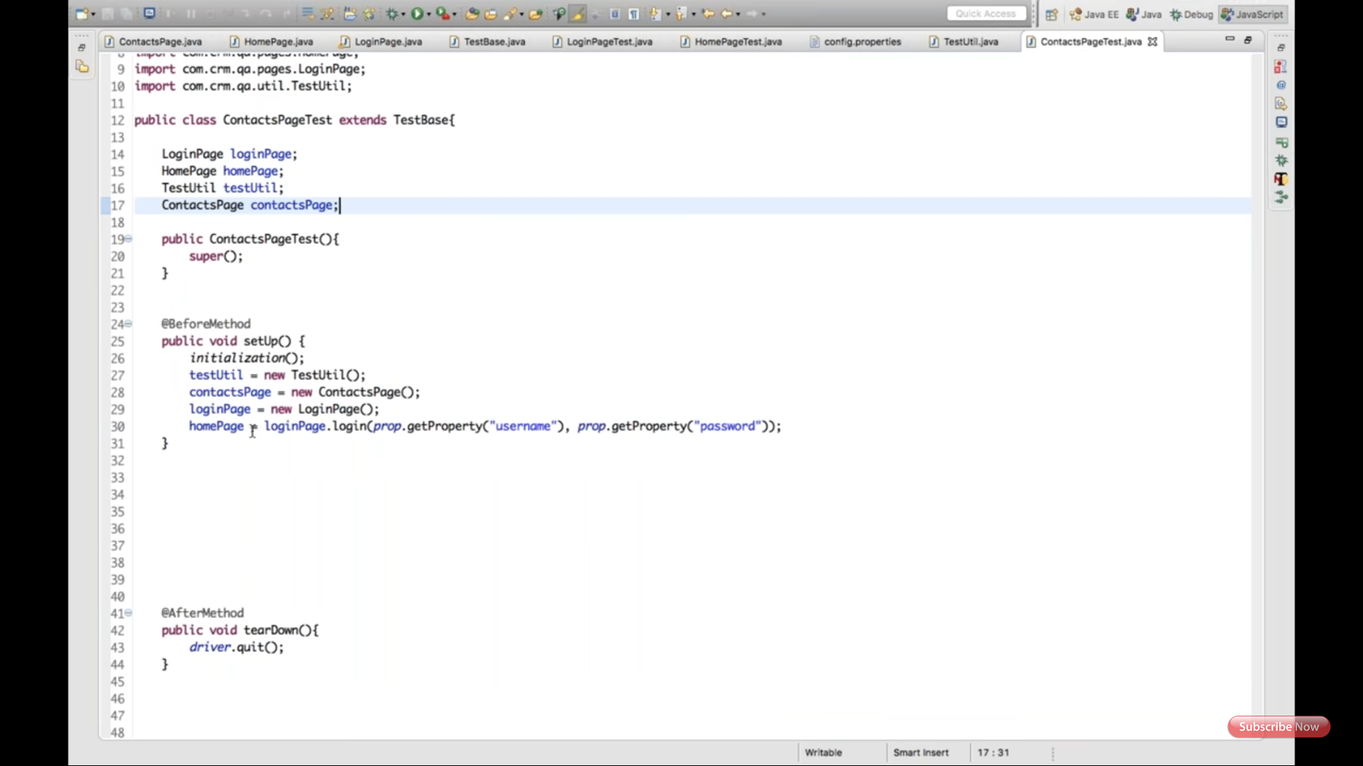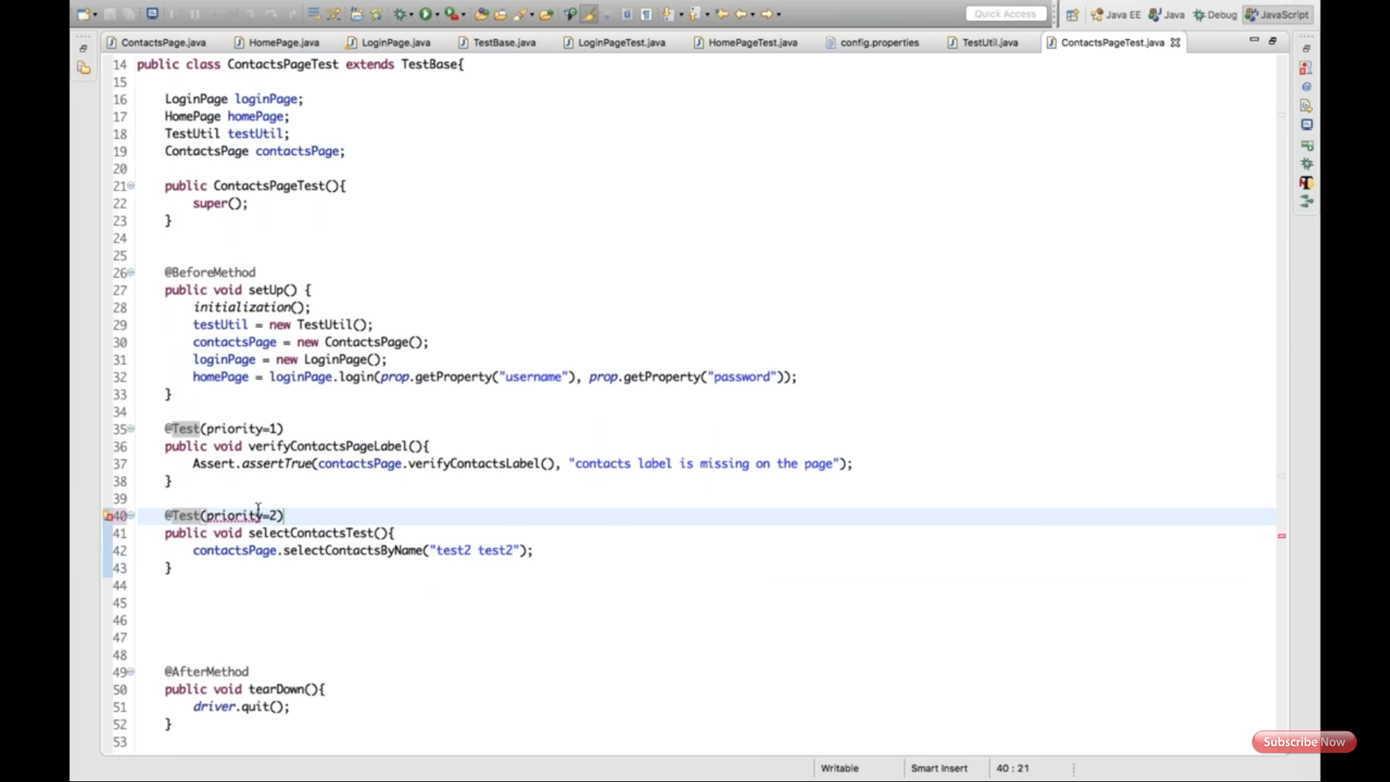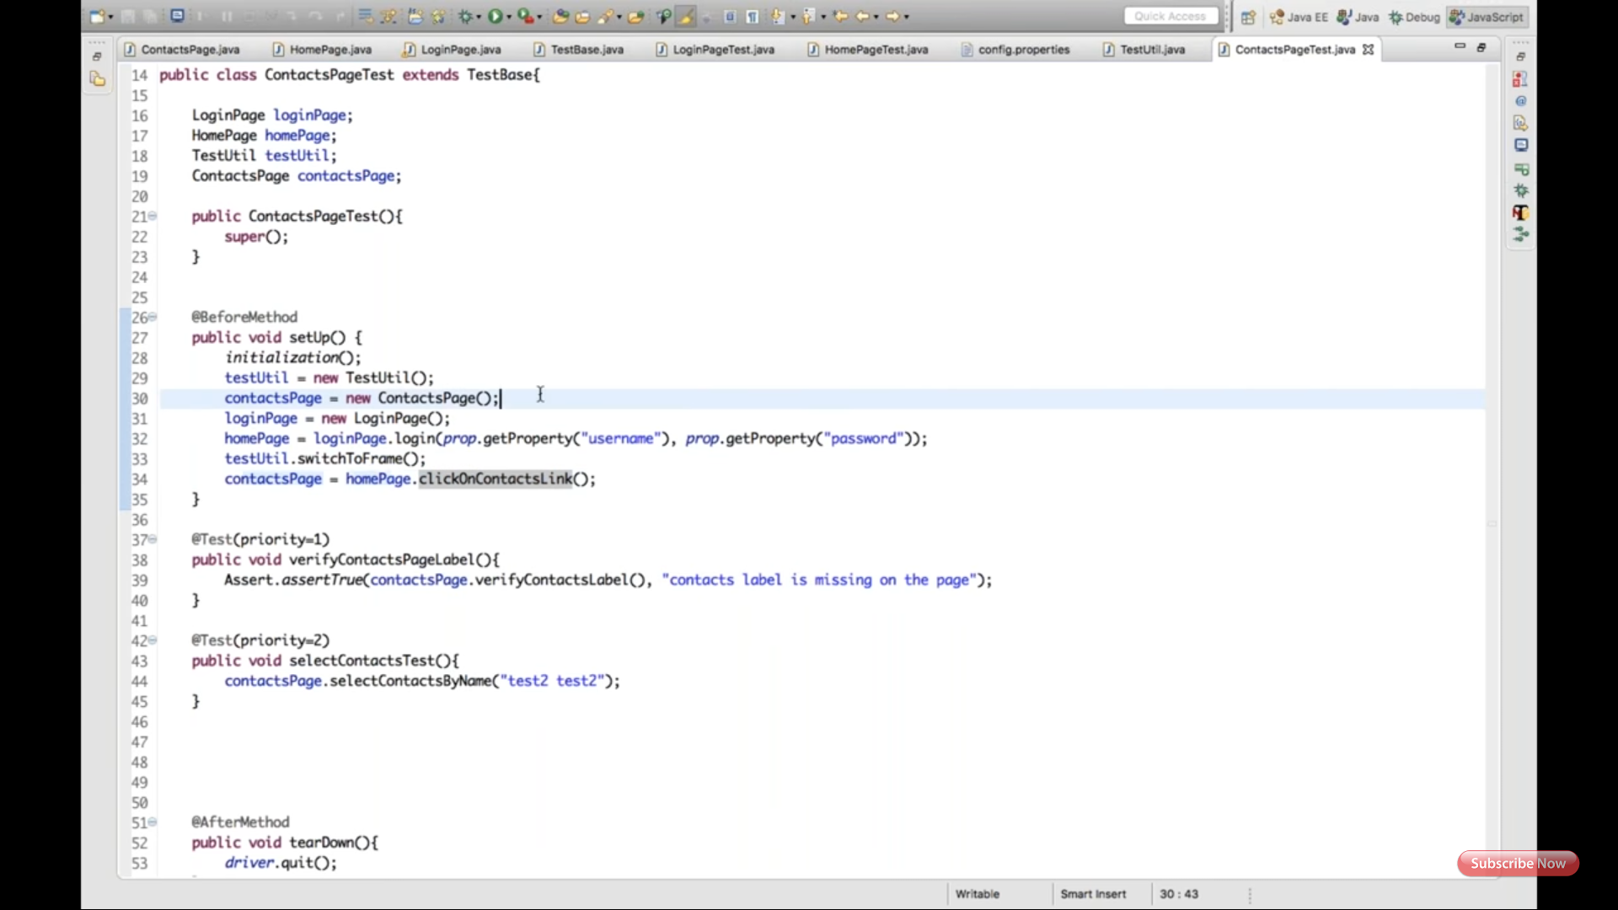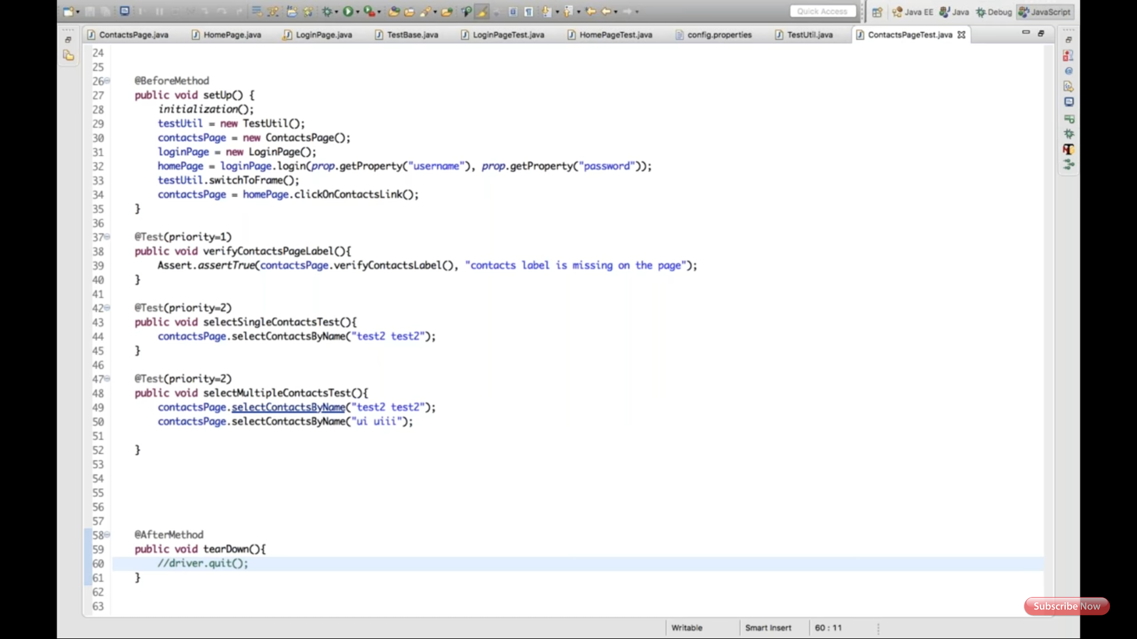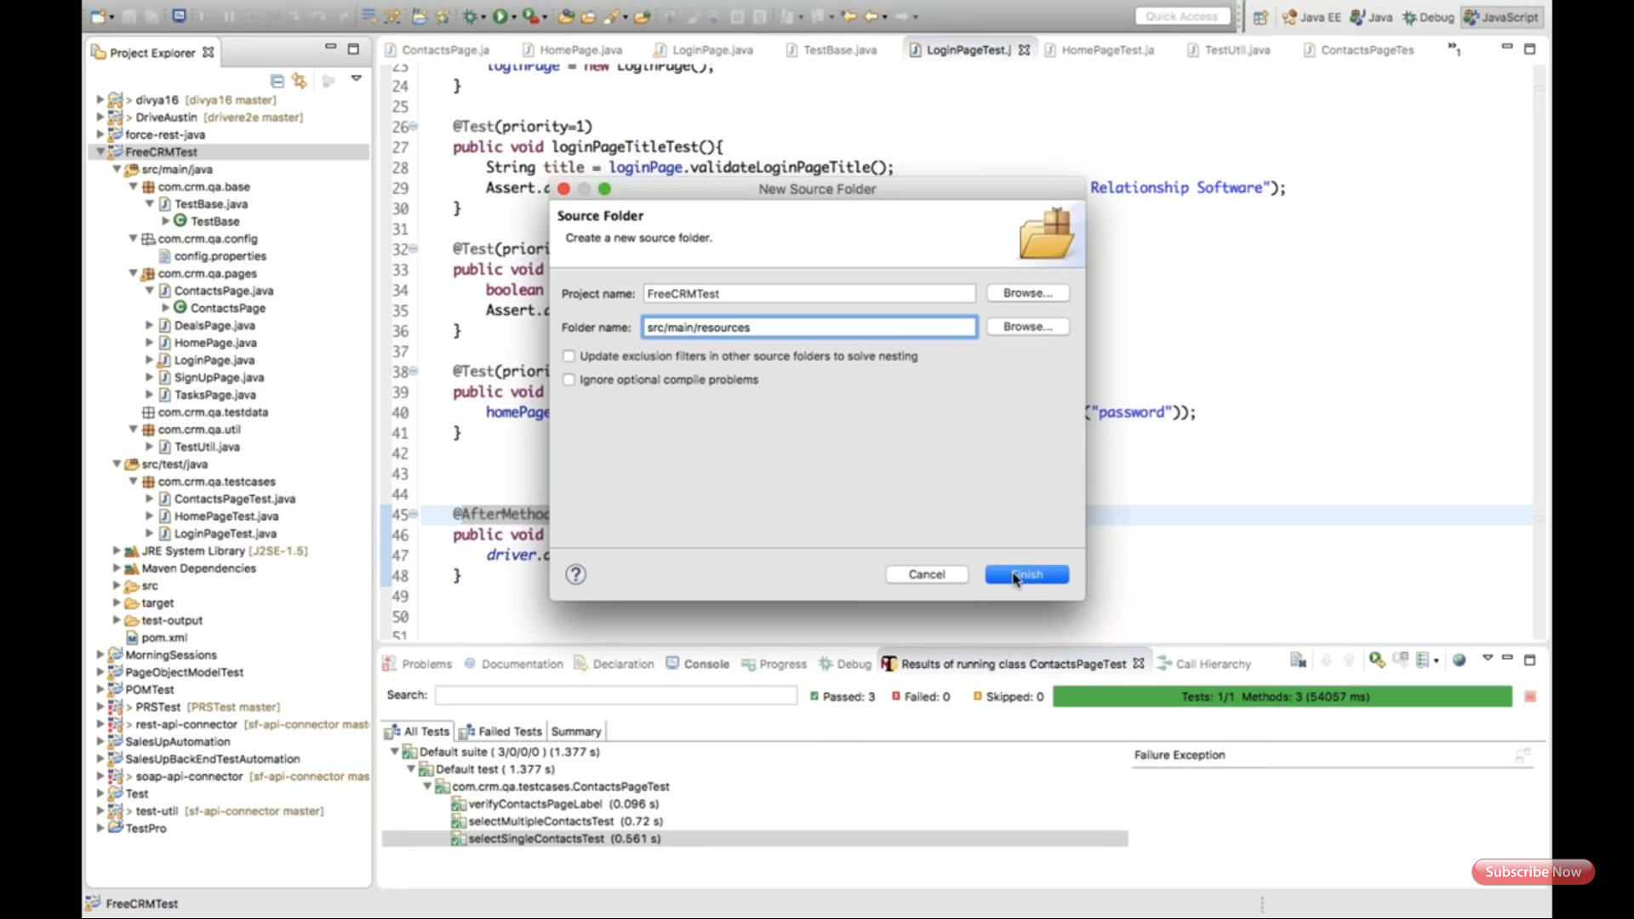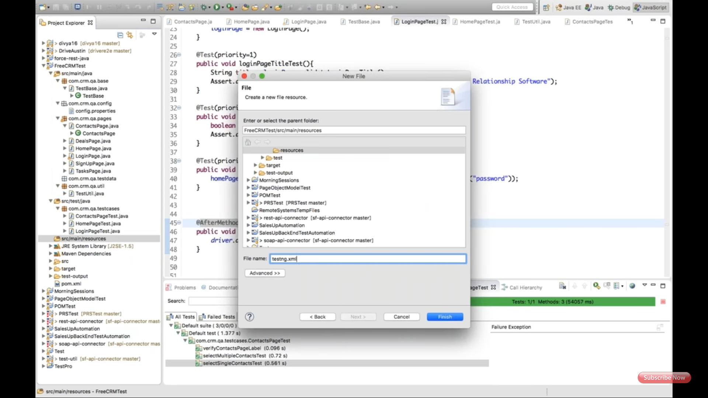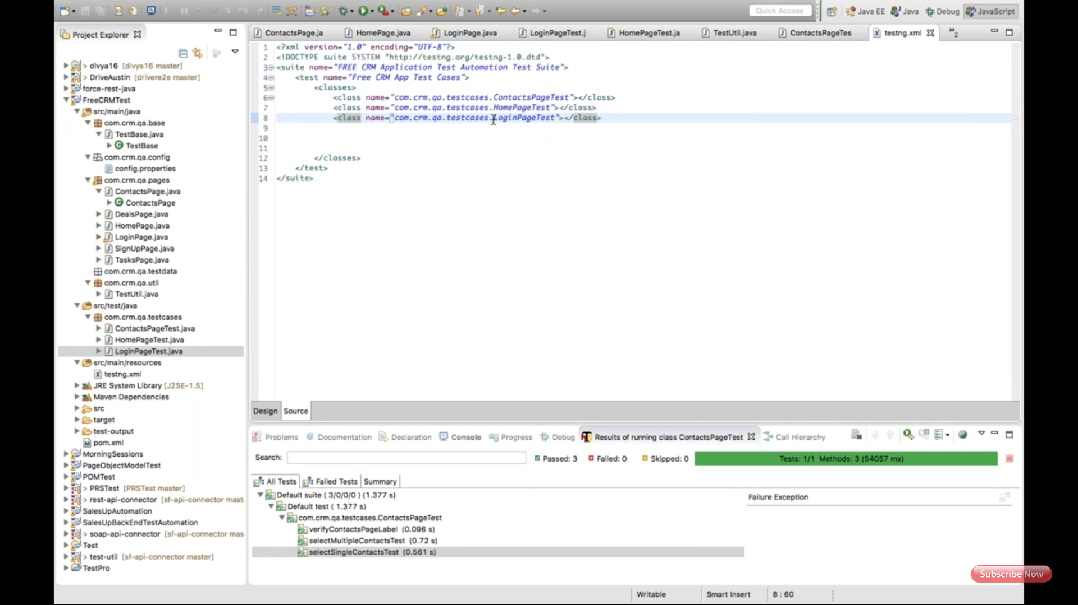

**Session on**

*Data provider*

*Cache lookup*

*Fire event*

First screenshot explains, creating method to click on New contact in HomePage class.

Second screenshot explains, creatNewContact method under ContactPage.

Third screenshot explains, contactPageTest method to create contact using hard code value.

Forth screenshot explains, creating Excel sheet and save under com.qe.test.testdata package.

5&6th GetTestData method and path under TestUtil class.

7th, string sheetname;

8th, @DataProvider created under testContact class.

9th, uses Data provider in @test and test method as parameters.

10th @cacheLookup used to speed of the finding eleminates. Need to use under page factory after declaration of @FindBy

11th, It's good it will not read html every time to validate eleminates, it creates one cache memory for all the elements and read from there. But problem is, if web page get refreshed, if DOM structure changed, it throws StaleElementException.

PDF, create one WebEventListener.class under TestUtil.  !!!!!!!  This is very useful for log creation for every web event it generate logs in console.

12th show creating WebEventListener object under TestBase class.(concept is called as WEB DRIVER FIRE EVENT)

13th, onException method under WebEventListenerClass S.O.P. exception and take screenshot.

14, 15 and 16th of, put the take screenshot method under TestUtil. For widows change path accordingly. It creates screenshot folder under Maven project and store it.

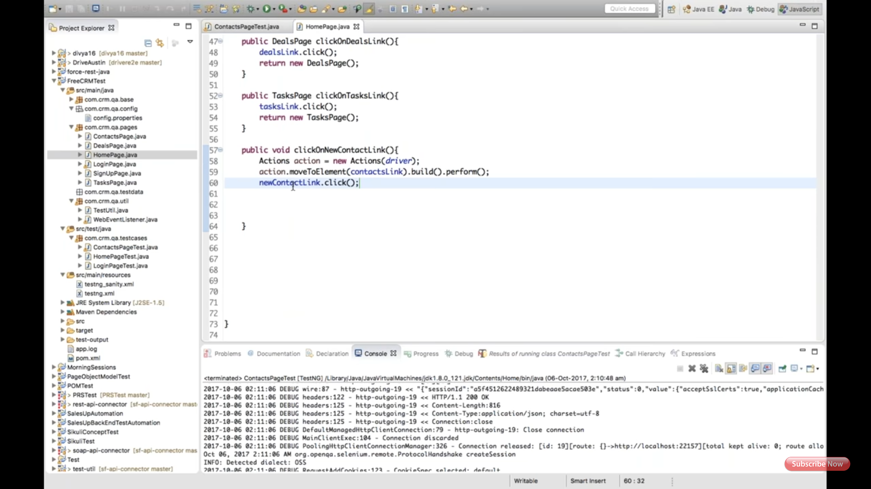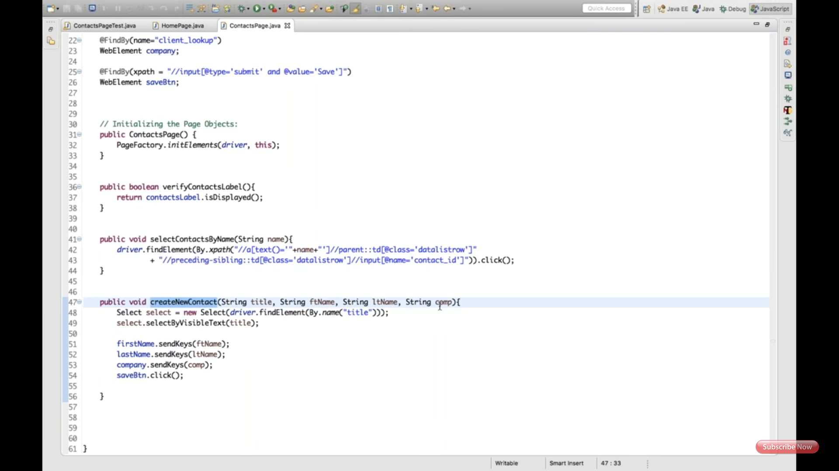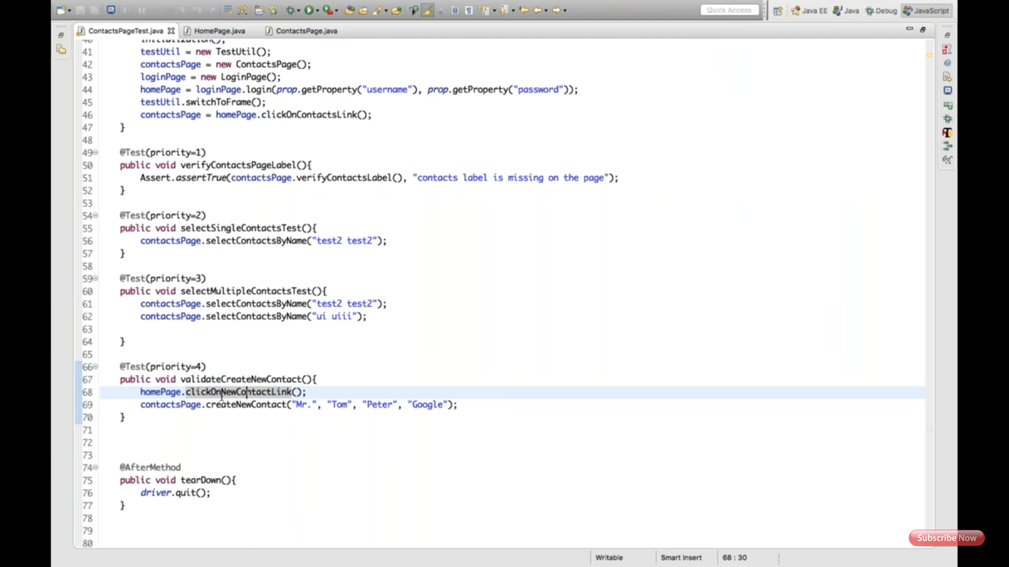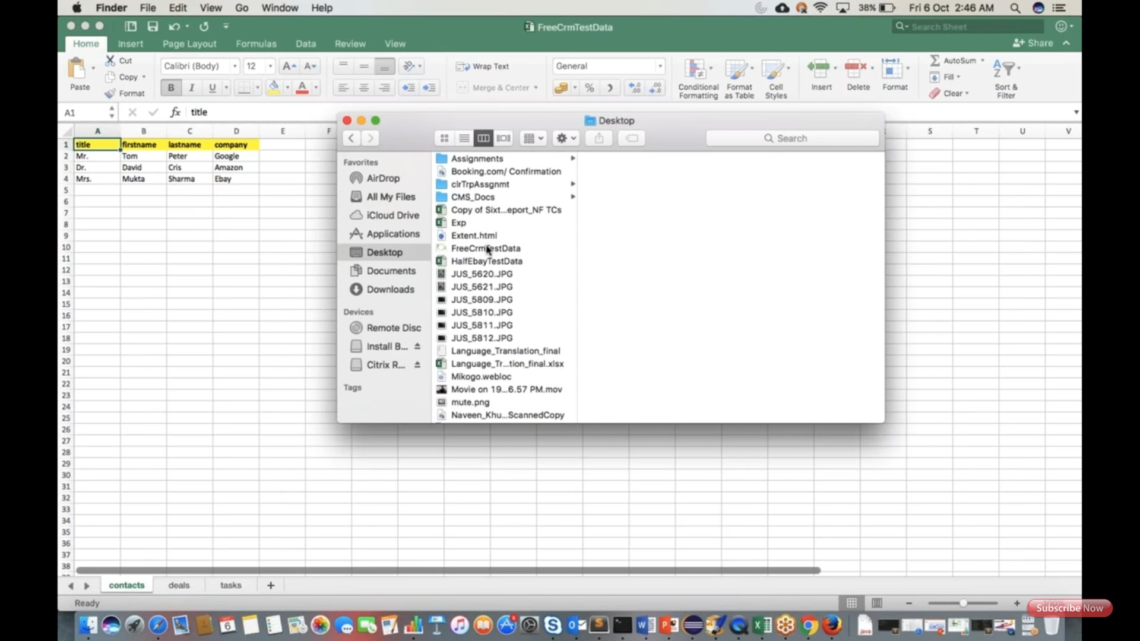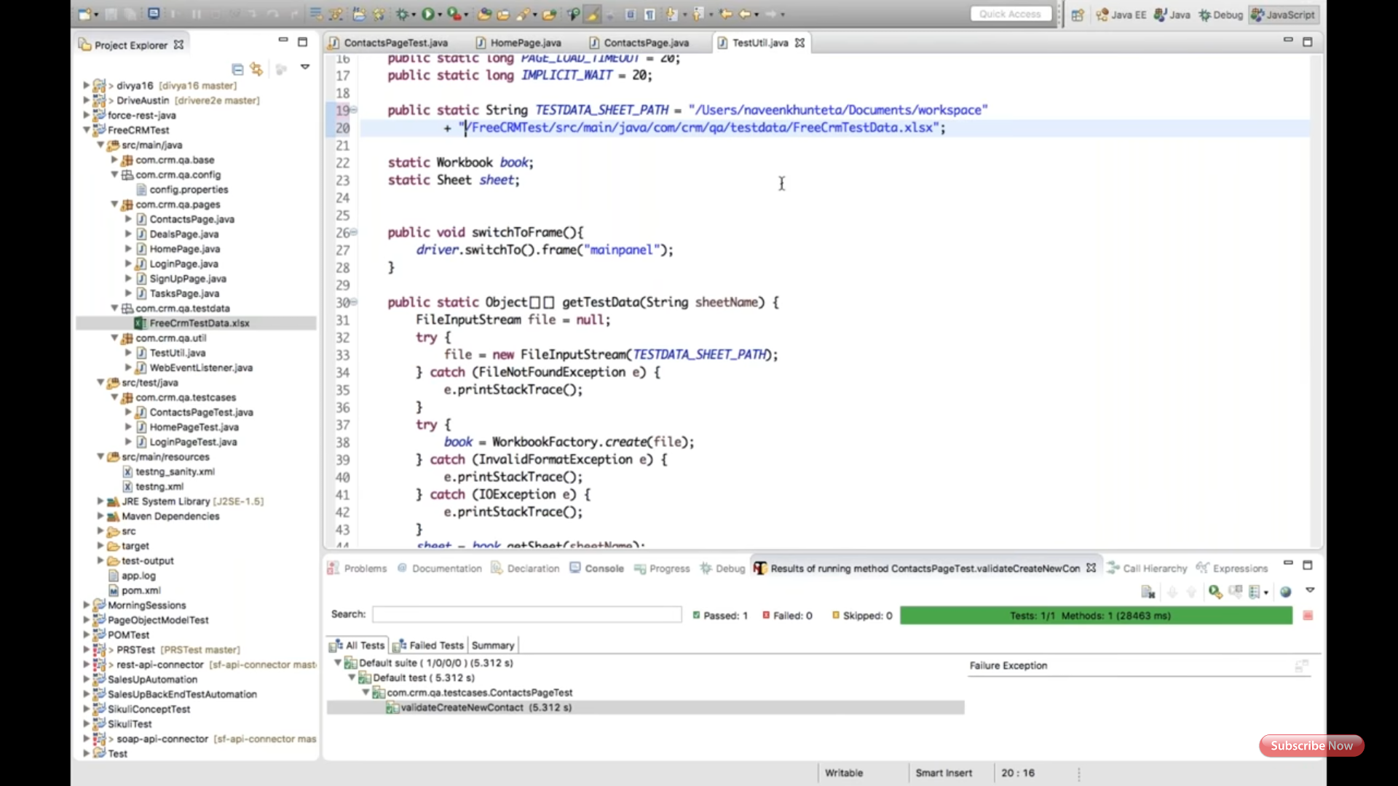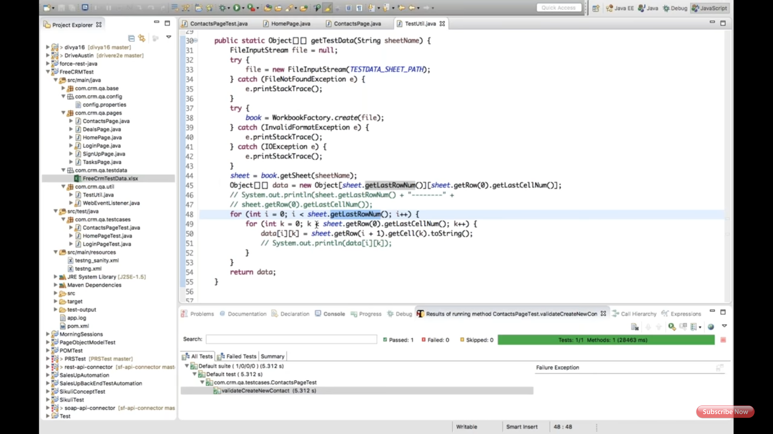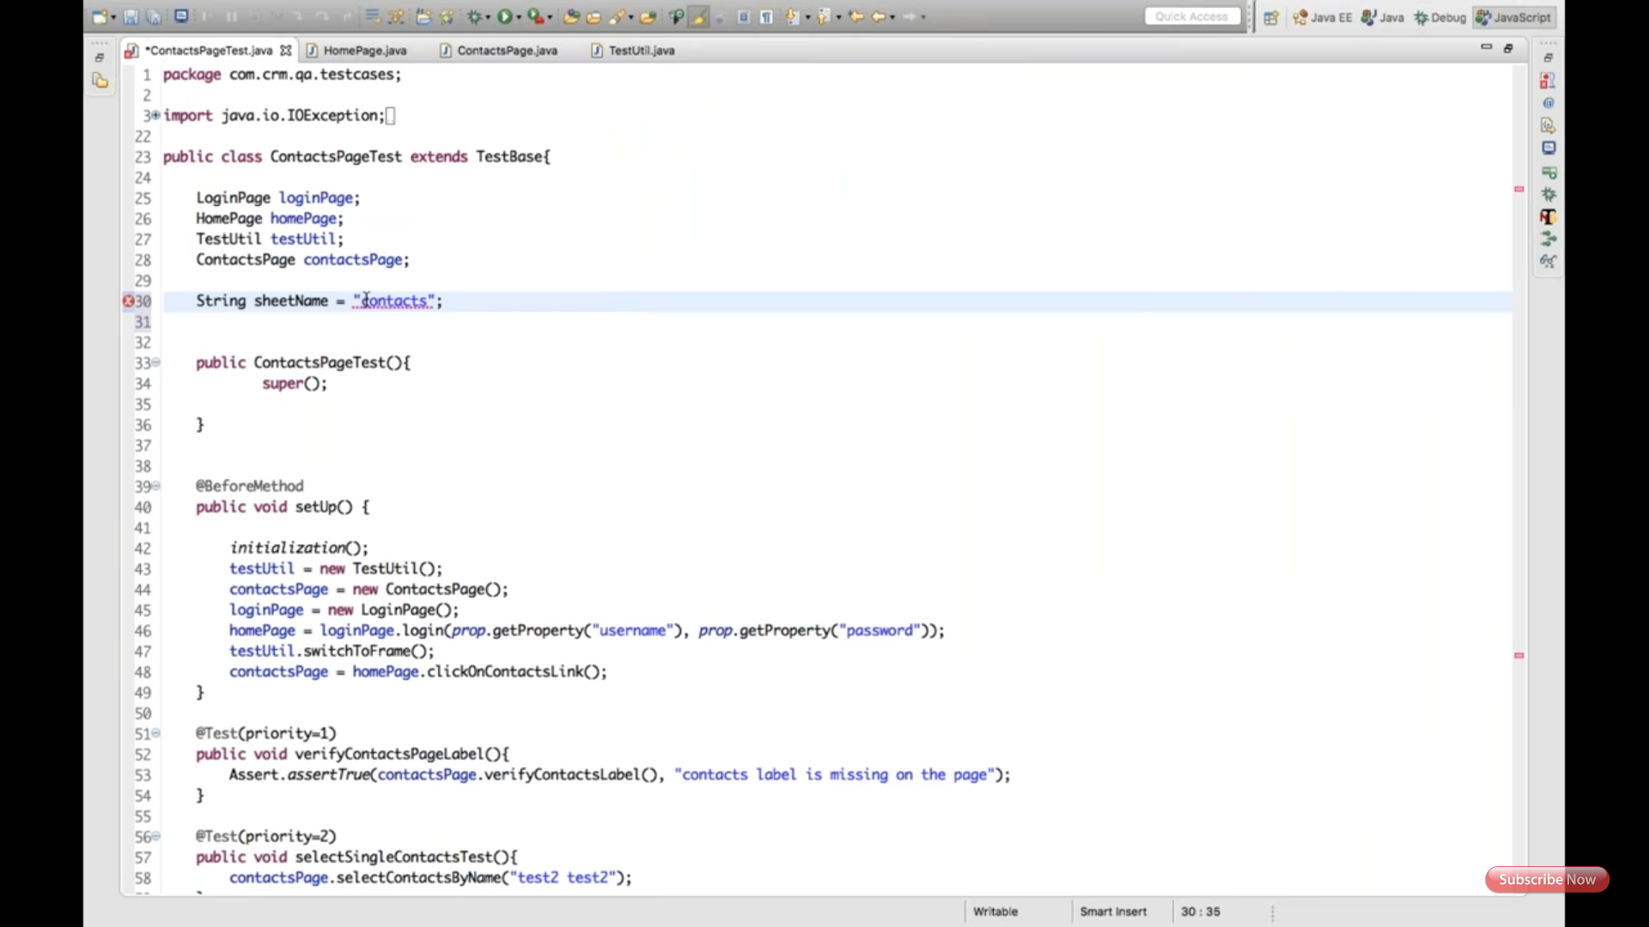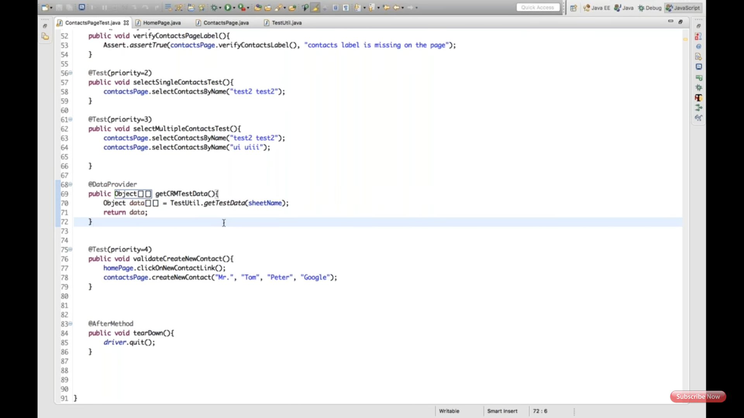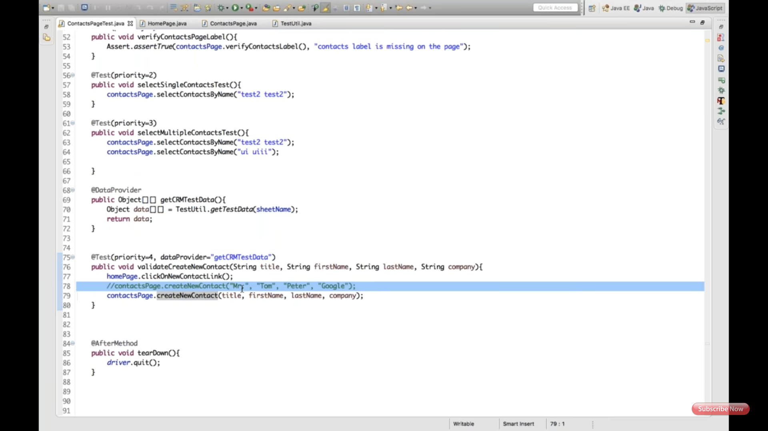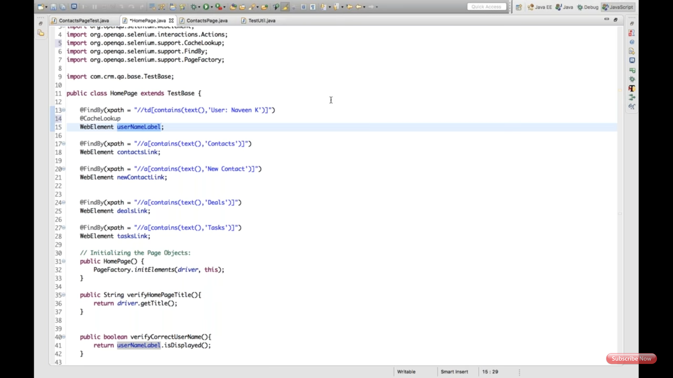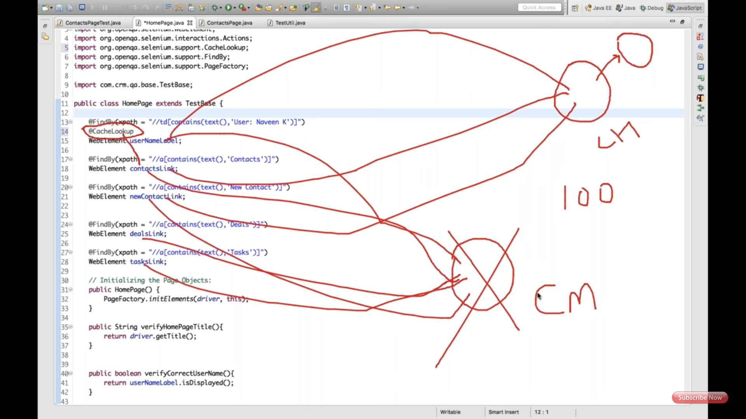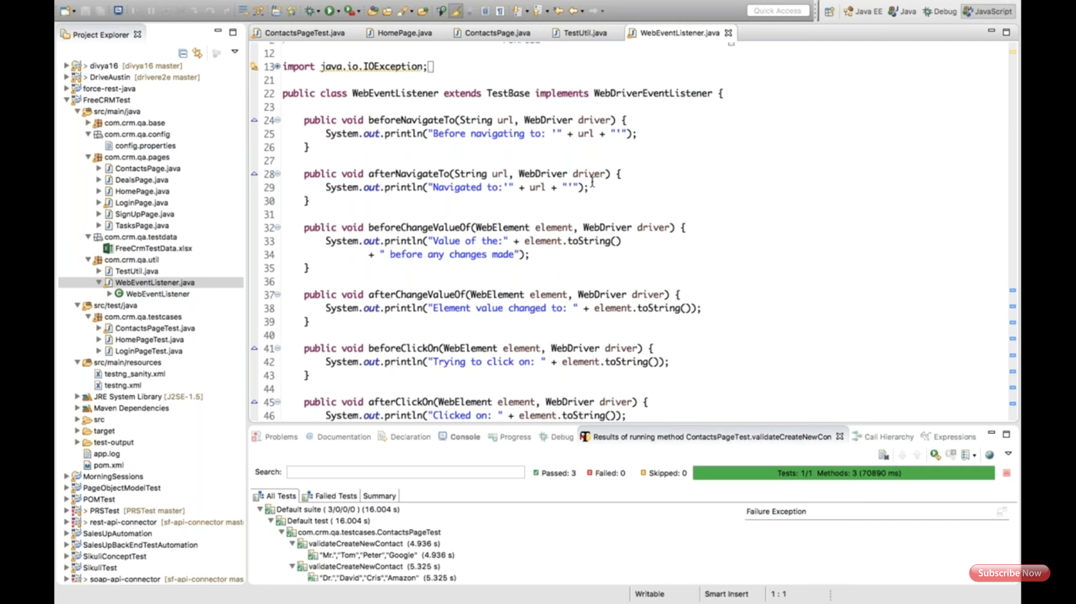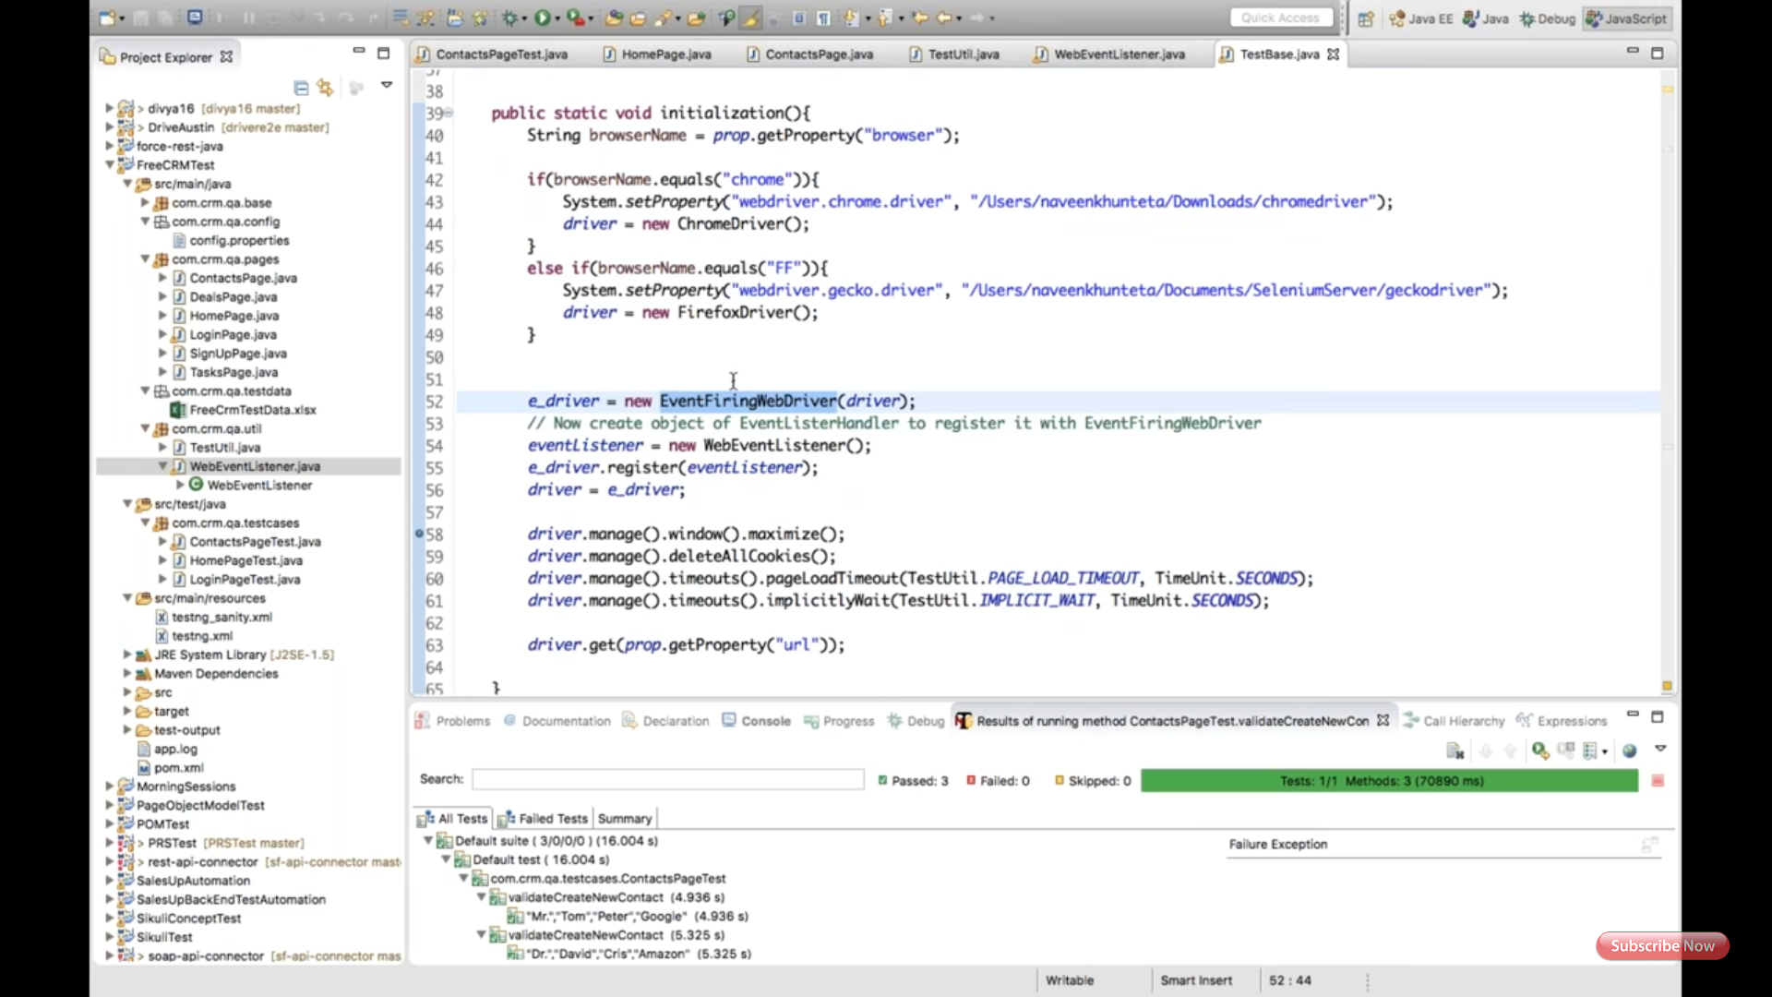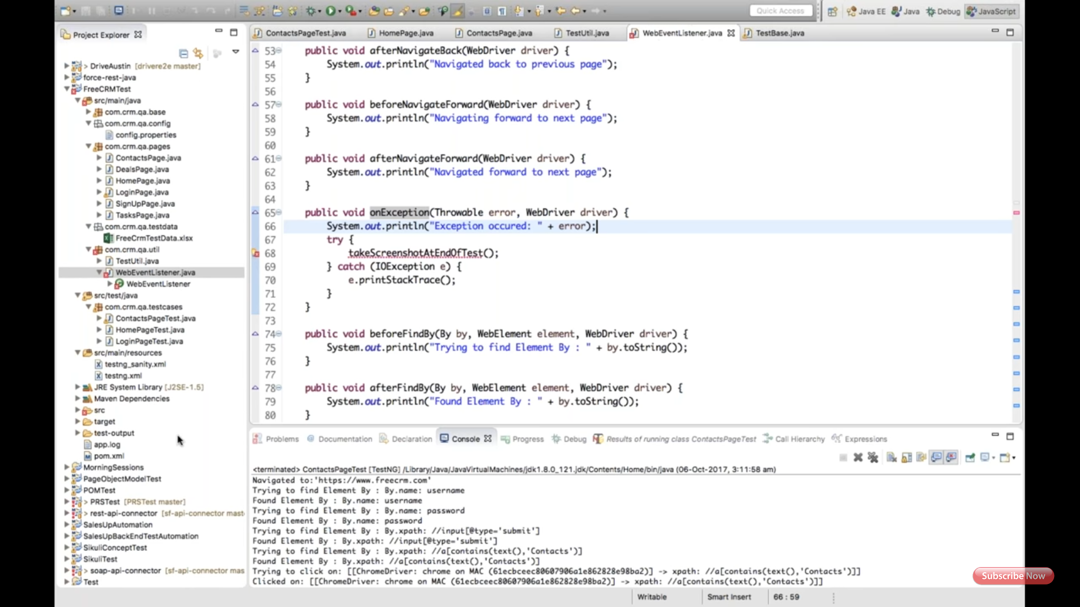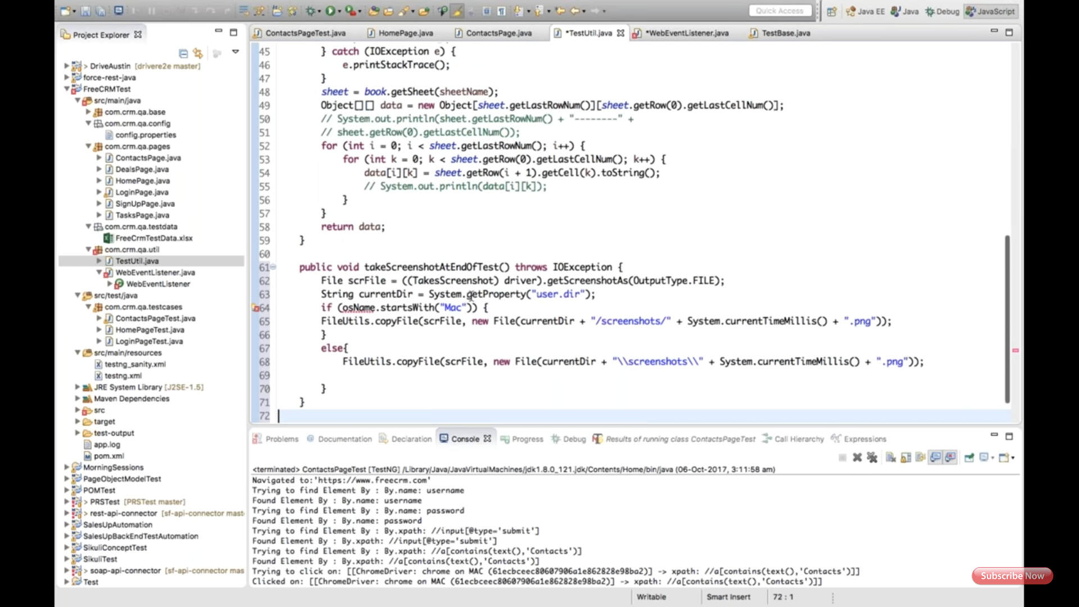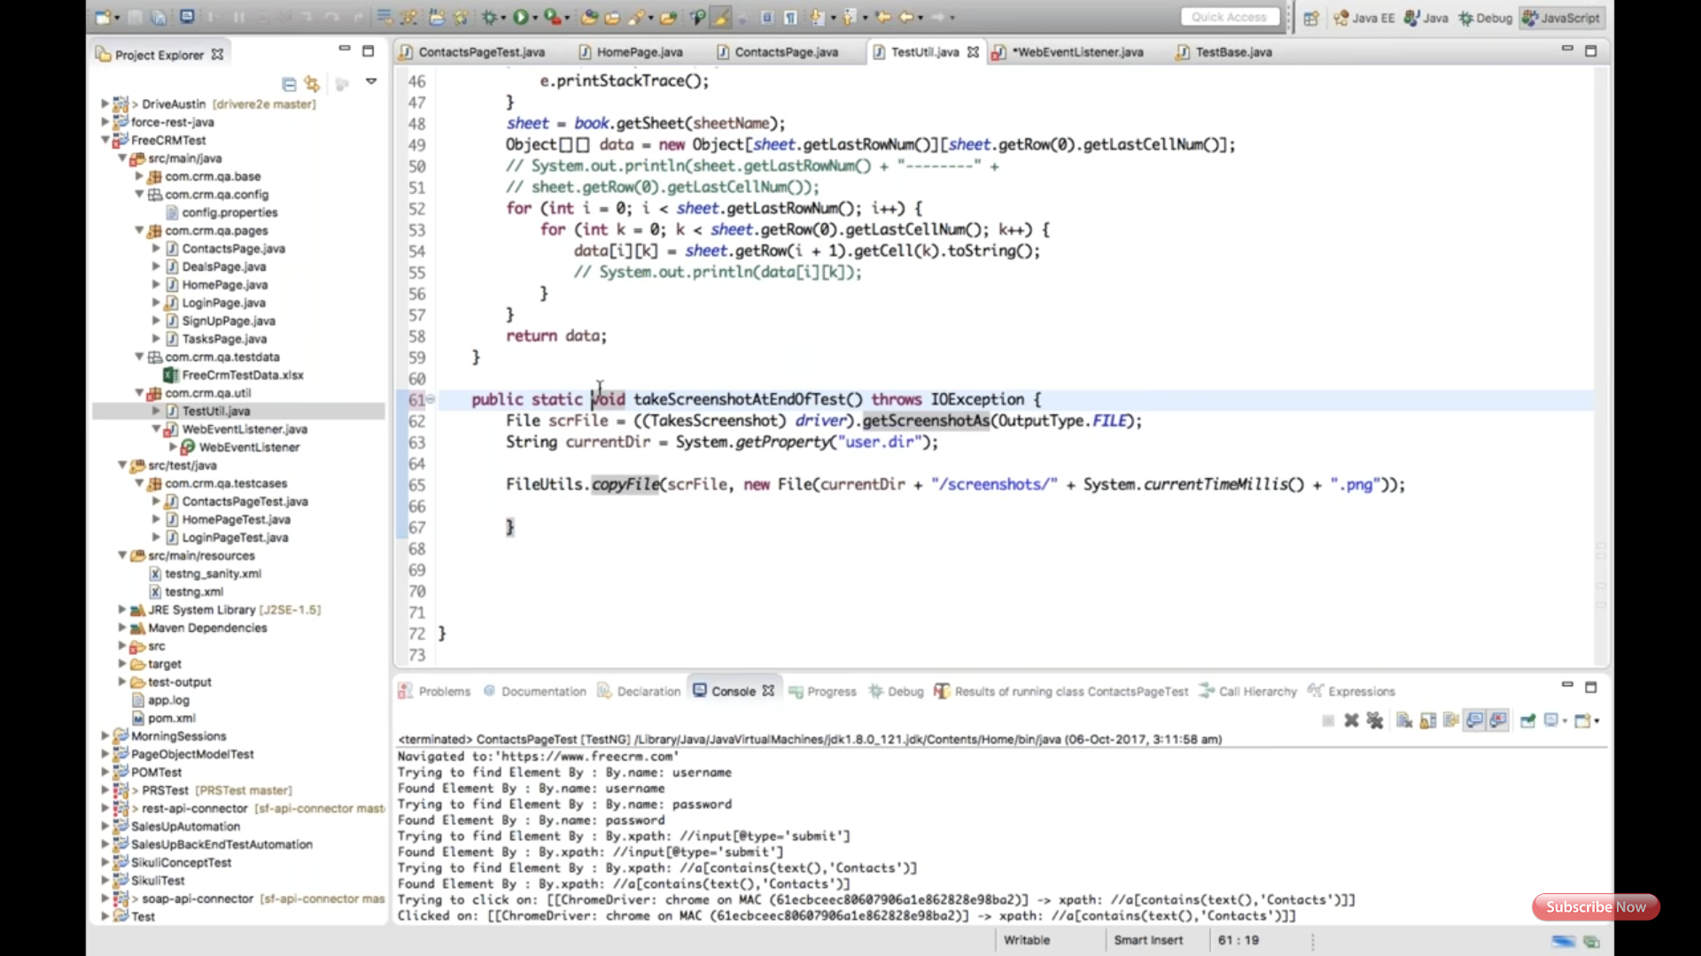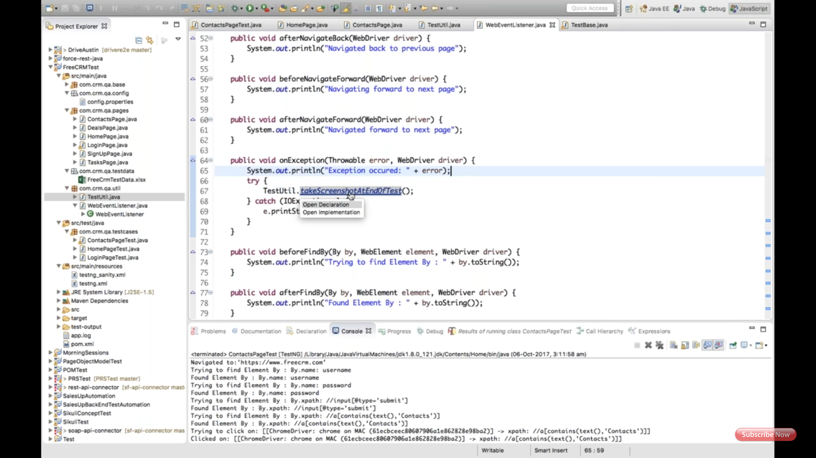

1st screenshot explains, dependency of extend report.

2nd, create package under src.main with package name: extentReportListener

3rd, create ExtentReportListener class under extentReportListener package.  Copy paste the code. Using attached PDF.

4th, add one section under TestNG.xml

5th, after test run it generate report under test out folder with name: Extent.html

Below are the screens:

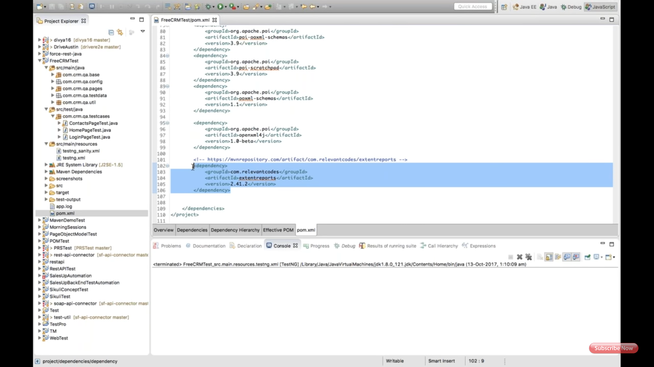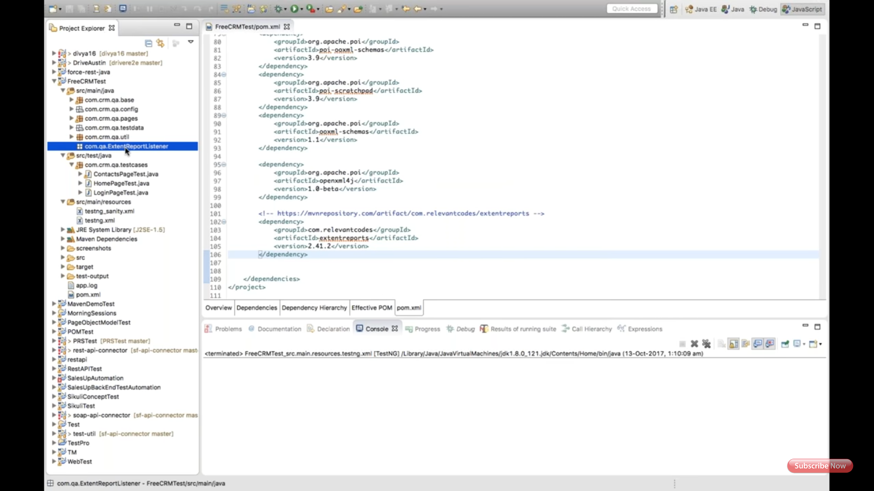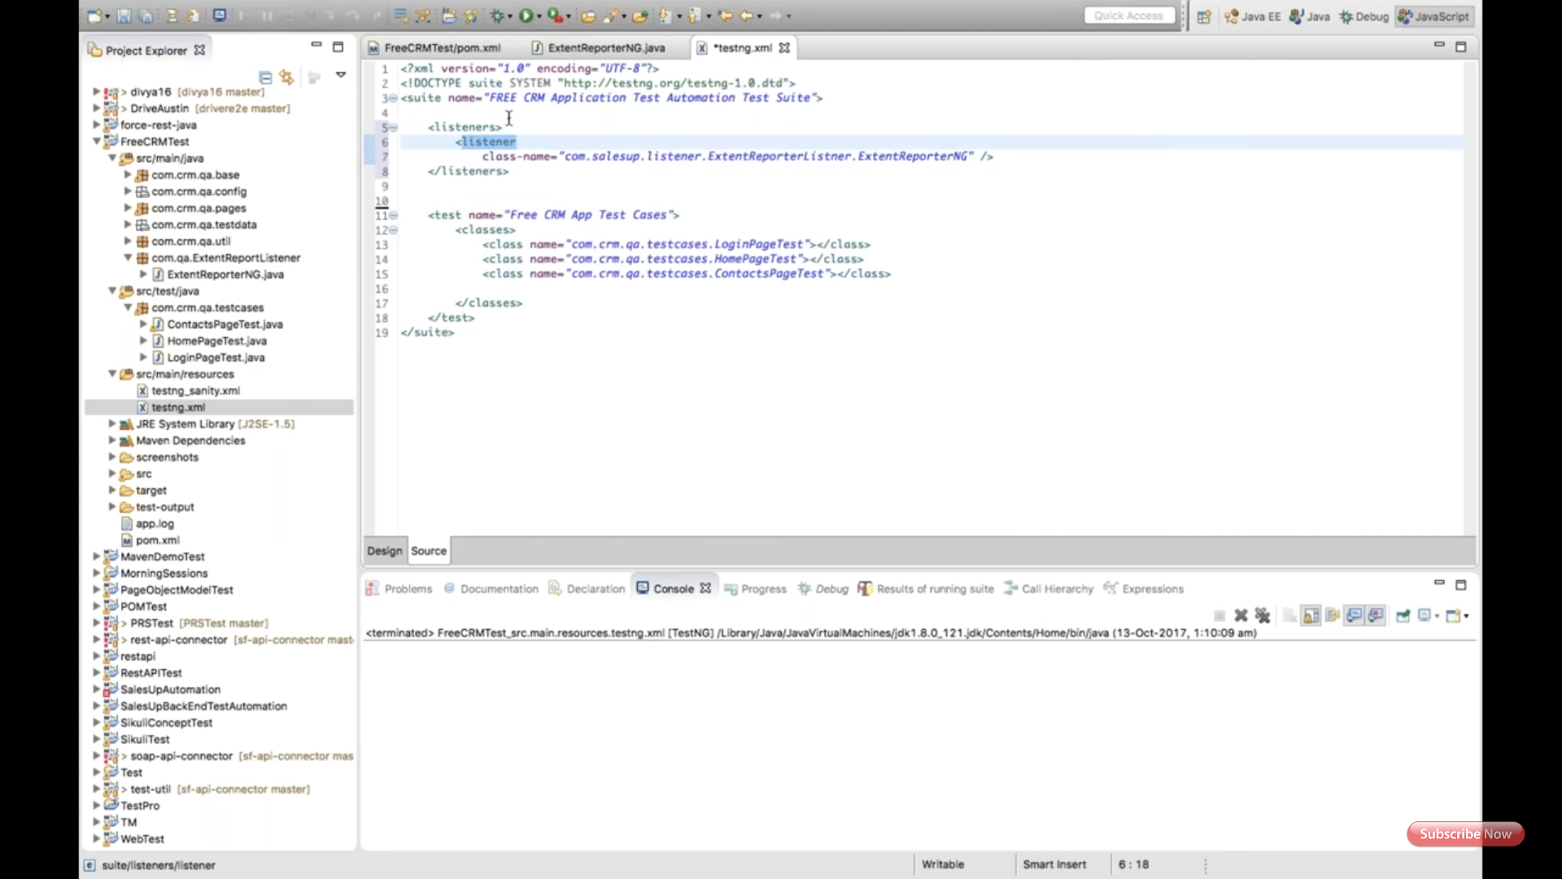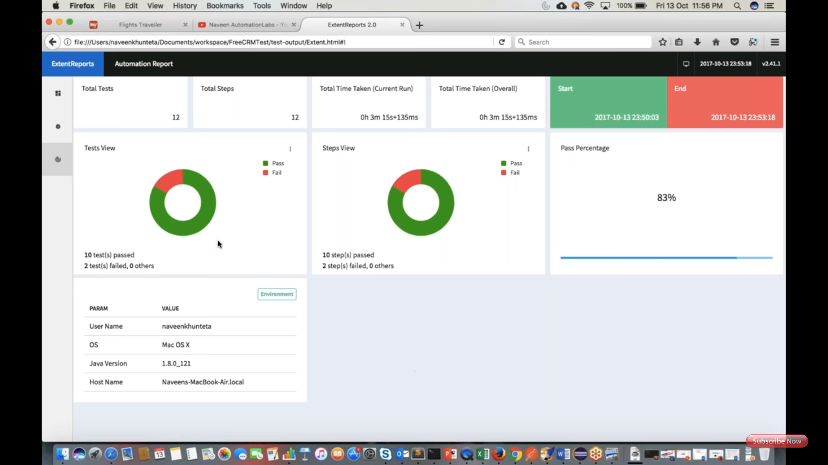

**ExtentReporterNG Class:**

package com.att.qa.ExtentReportListener;

/* * Vishnu GC * */

import java.io.File;

import java.util.Calendar;

import java.util.Date;

import java.util.List;

import java.util.Map;

import org.testng.IReporter;

import org.testng.IResultMap;

import org.testng.ISuite;

import org.testng.ISuiteResult;

import org.testng.ITestContext;

import org.testng.ITestResult;

import org.testng.xml.XmlSuite;

import com.relevantcodes.extentreports.ExtentReports;

import com.relevantcodes.extentreports.ExtentTest;

import com.relevantcodes.extentreports.LogStatus;

public class ExtentReporterNG implements IReporter {

private ExtentReports extent;

public void generateReport(List<XmlSuite> xmlSuites, List<ISuite> suites, String outputDirectory) {

extent = new ExtentReports(outputDirectory + File.separator + "Extent.html", true);

for (ISuite suite : suites) { Map<String, ISuiteResult> result = suite.getResults();

for (ISuiteResult r : result.values()) { ITestContext context = r.getTestContext();

buildTestNodes(context.getPassedTests(), LogStatus.PASS);

buildTestNodes(context.getFailedTests(), LogStatus.FAIL);

buildTestNodes(context.getSkippedTests(), LogStatus.SKIP);

}

}

extent.flush(); extent.close();

}

private void buildTestNodes(IResultMap tests, LogStatus status) {

ExtentTest test;

if (tests.size() > 0) { for (ITestResult result : tests.getAllResults()) {

test = extent.startTest(result.getMethod().getMethodName());

test.setStartedTime(getTime(result.getStartMillis()));

test.setEndedTime(getTime(result.getEndMillis()));

for (String group : result.getMethod().getGroups()) test.assignCategory(group);

if (result.getThrowable() != null) {

test.log(status, result.getThrowable());

} else {

test.log(status, "Test " + status.toString().toLowerCase() + "ed");

}

extent.endTest(test);

}

}

}

private Date getTime(long millis) {

Calendar calendar = Calendar.getInstance();

calendar.setTimeInMillis(millis);

return calendar.getTime();

}

}